Lenin on the Proletariat Revolution
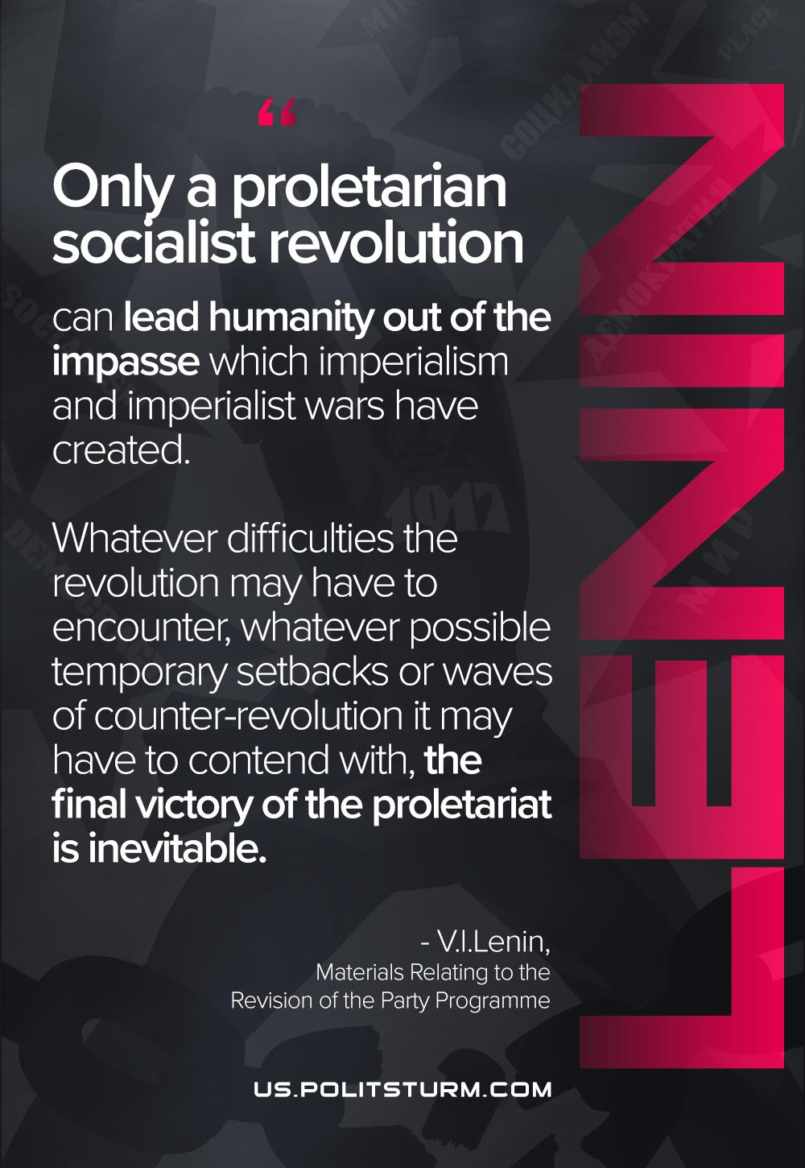

Original article
2021-06-21

Only a proletarian socialist revolution can lead humanity out of the impasse which imperialism and imperialist wars have created. Whatever difficulties the revolution may have to encounter, whatever possible temporary setbacks or waves of counter-revolution it may have to contend with, the final victory of the proletariat is inevitable.
Vladimir Lenin, “Materials Relating to the Revision of the Party Programme”

Original article

