Lenin on the Proletariat Militia
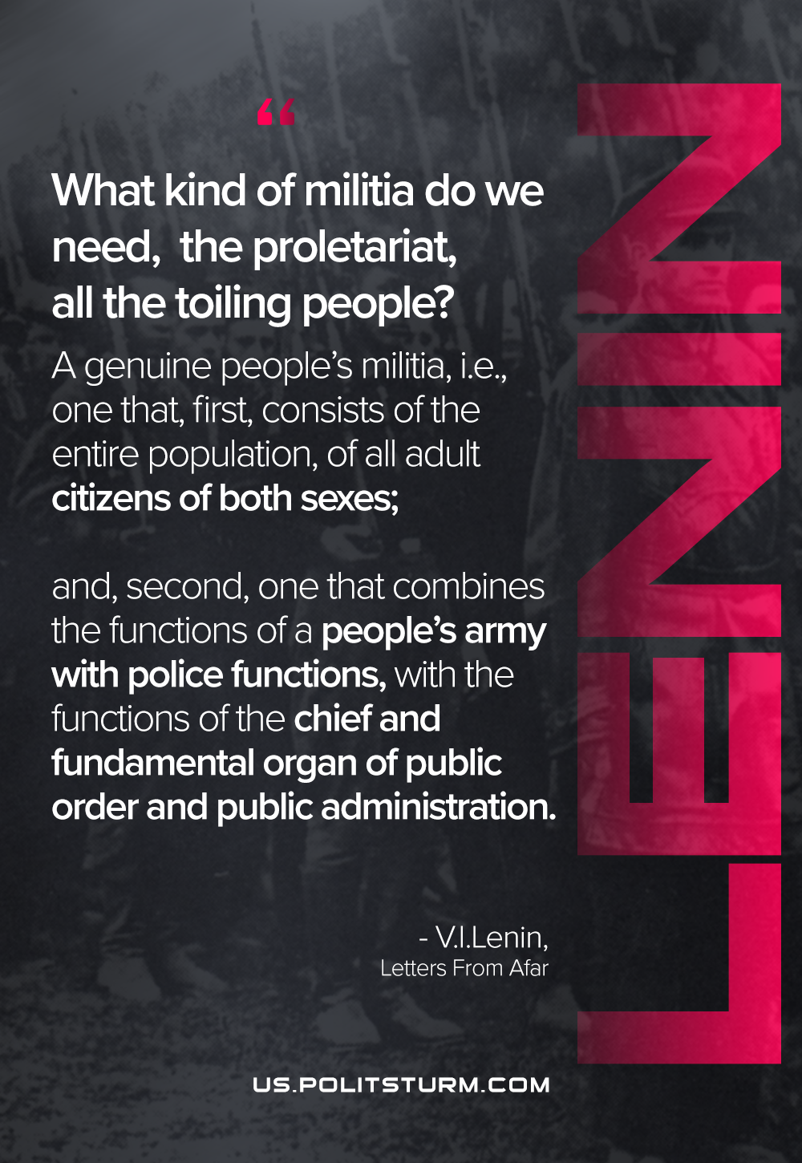

Original article
2021-06-25

What kind of militia do we need, the proletariat, all the toiling people? A genuine people’s militia, i.e., one that, first, consists of the entire population, of all adult citizens of both sexes; and, second, one that combines the functions of a people’s army with police functions, with the functions of the chief and fundamental organ of public order and public administration.
Vladimir Lenin, “Letters From Afar”

Original article

