Lenin on the Proletarian Cause Coming First
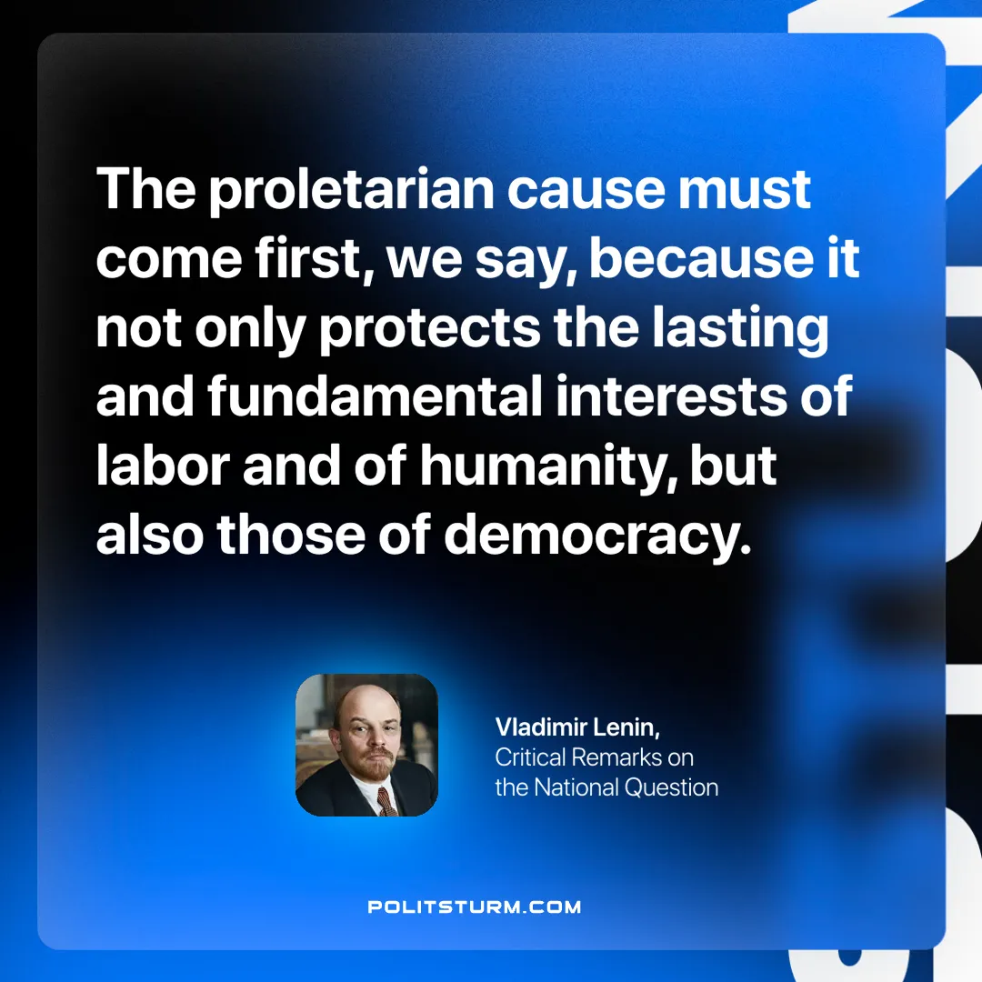

Original article
2024-10-22

“The proletarian cause must come first, we say, because it not only protects the lasting and fundamental interests of labor and of humanity, but also those of democracy.”
Vladimir Lenin, Critical Remarks on the National Question

Original article

