Lenin On The Principle of Capitalism
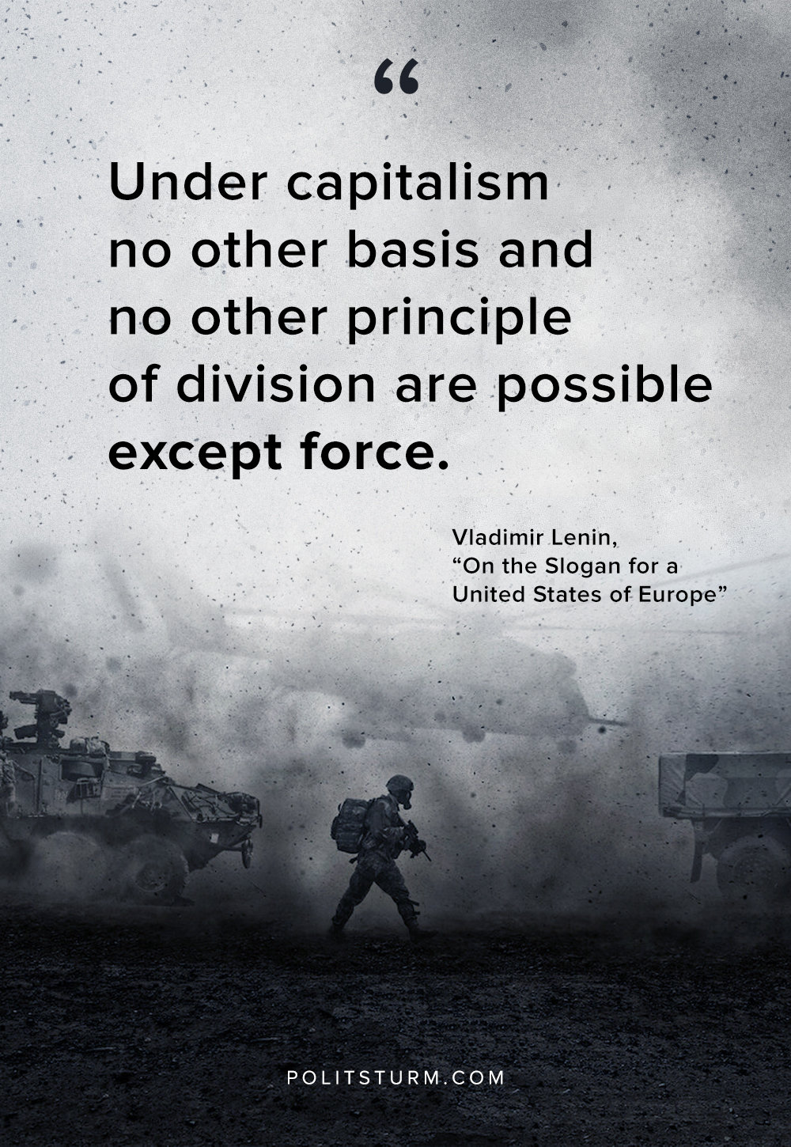

Original article
2020-03-03

“Under capitalism no other basis and no other principle of division are possible except force.”
V.I.Lenin, “On the Slogan for a United States of Europe”

Original article

