Lenin on the Present Economic System
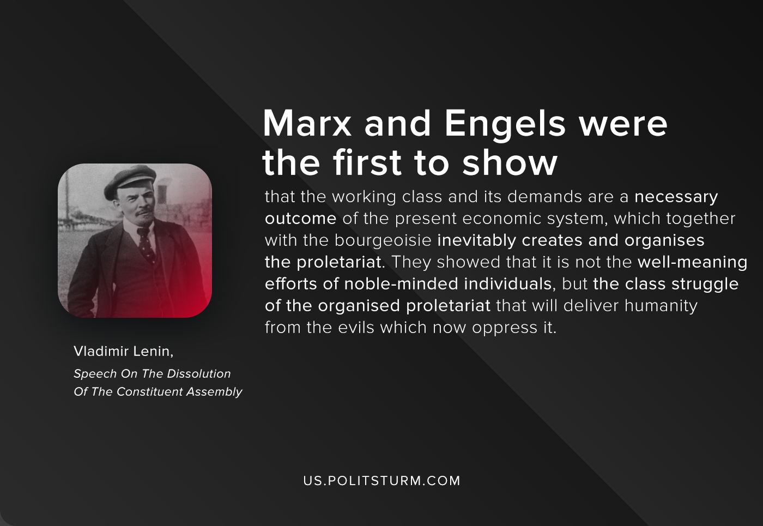

Original article
2020-07-20

Marx and Engels were the first to show that the working class and its demands are a necessary outcome of the present economic system, which together with the bourgeoisie inevitably creates and organises the proletariat.
They showed that it is not the well-meaning efforts of noble-minded individuals, but the class struggle of the organised proletariat that will deliver humanity from the evils which now oppress it.

Original article

