Lenin on the Position of the Lower Classes to the Existing Order
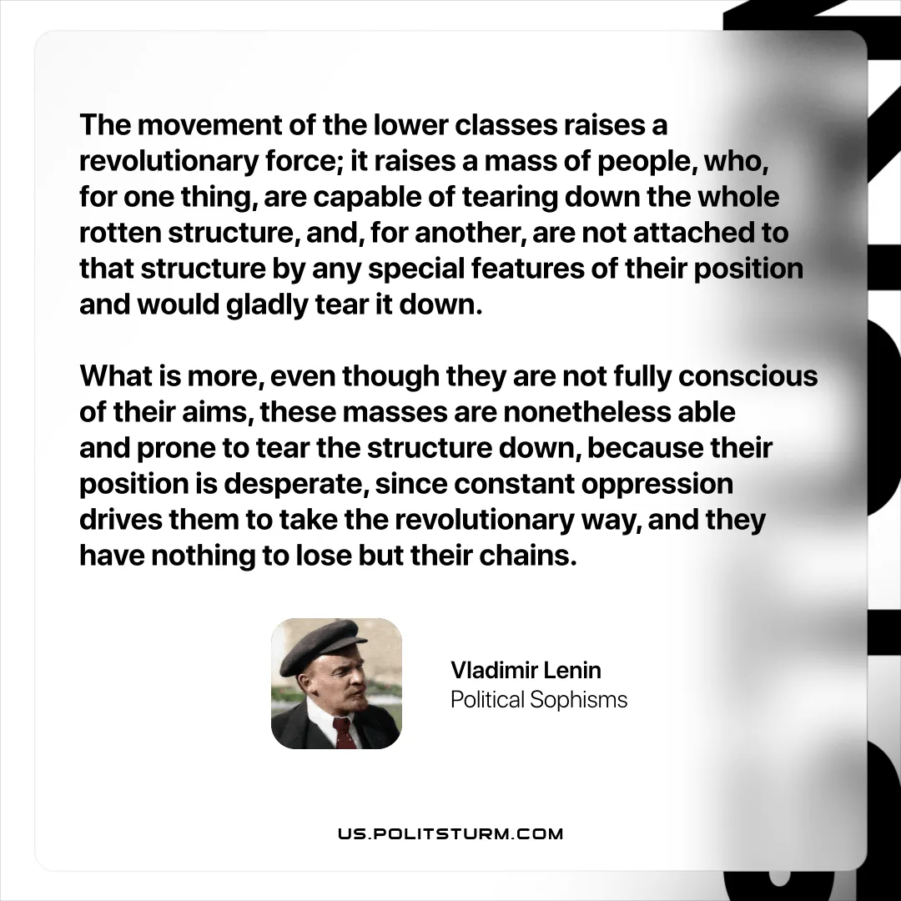

Original article
2025-11-16
1 min read

“The movement of the lower classes raises a revolutionary force; it raises a mass of people, who, for one thing, are capable of tearing down the whole rotten structure, and, for another, are not attached to that structure by any special features of their position and would gladly tear it down. What is more, even though they are not fully conscious of their aims, these masses are nonetheless able and prone to tear the structure down, because their position is desperate, since constant oppression drives them to take the revolutionary way, and they have nothing to lose but their chains.”
Vladimir Lenin, Political Sophisms

Original article

