Lenin on the Political Content of Social-Chauvinism and Opportunism
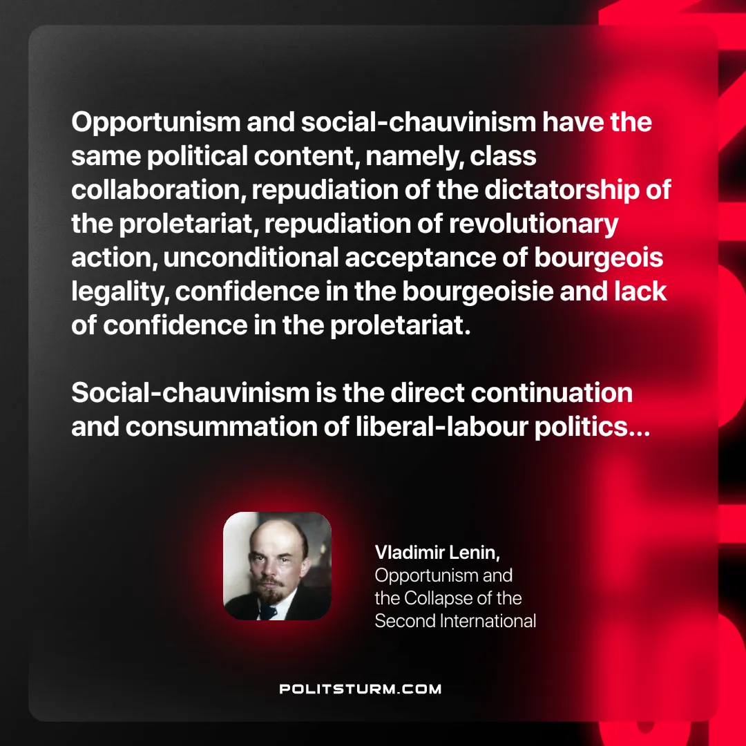

Original article
2025-05-18

“Opportunism and social-chauvinism have the same political content, namely, class collaboration, repudiation of the dictatorship of the proletariat, repudiation of revolutionary action, unconditional acceptance of bourgeois legality, confidence in the bourgeoisie and lack of confidence in the proletariat. Social-chauvinism is the direct continuation and consummation of [British] liberal-labour politics…”
Vladimir Lenin, Opportunism and the Collapse of the Second International

Original article

