Lenin on the Outcome of Ignoring Differences Between the Workers and Capitalists
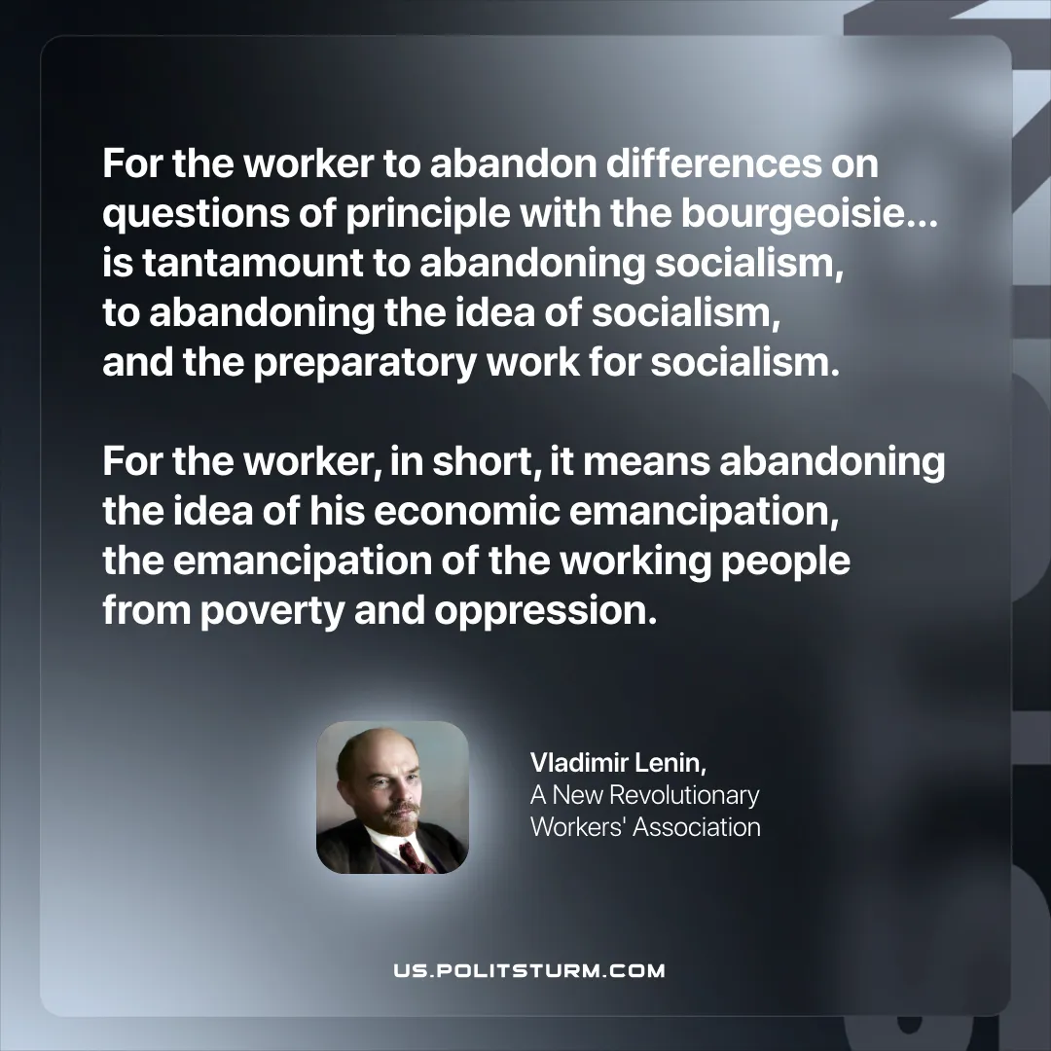

Original article
2025-09-30

“For the worker to abandon differences on questions of principle with the bourgeoisie… is tantamount to abandoning socialism, to abandoning the idea of socialism, and the preparatory work for socialism. For the worker, in short, it means abandoning the idea of his economic emancipation, the emancipation of the working people from poverty and oppression.”
Vladimir Lenin, A New Revolutionary Workers' Association

Original article

