Lenin on the Orgy of Pillage
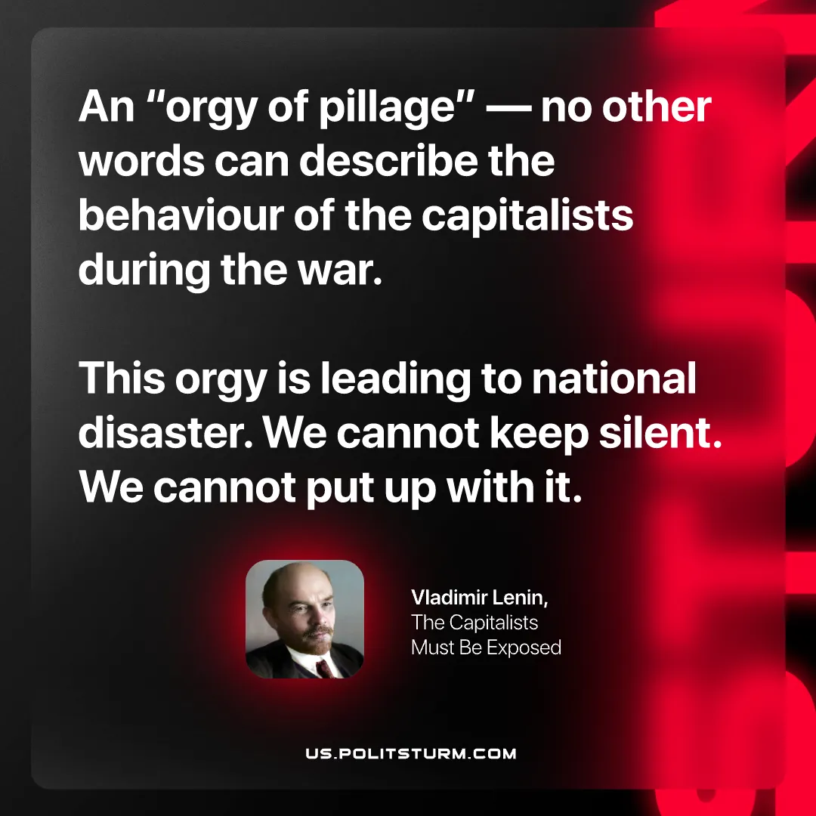

Original article
2026-09-10

An "orgy of pillage" — no other words can describe the behaviour of the capitalists during the war. This orgy is leading to national disaster. We cannot keep silent. We cannot put up with it.
Vladimir Lenin, The Capitalists Must Be Exposed

Original article

