Lenin on the Oppression of the Working People
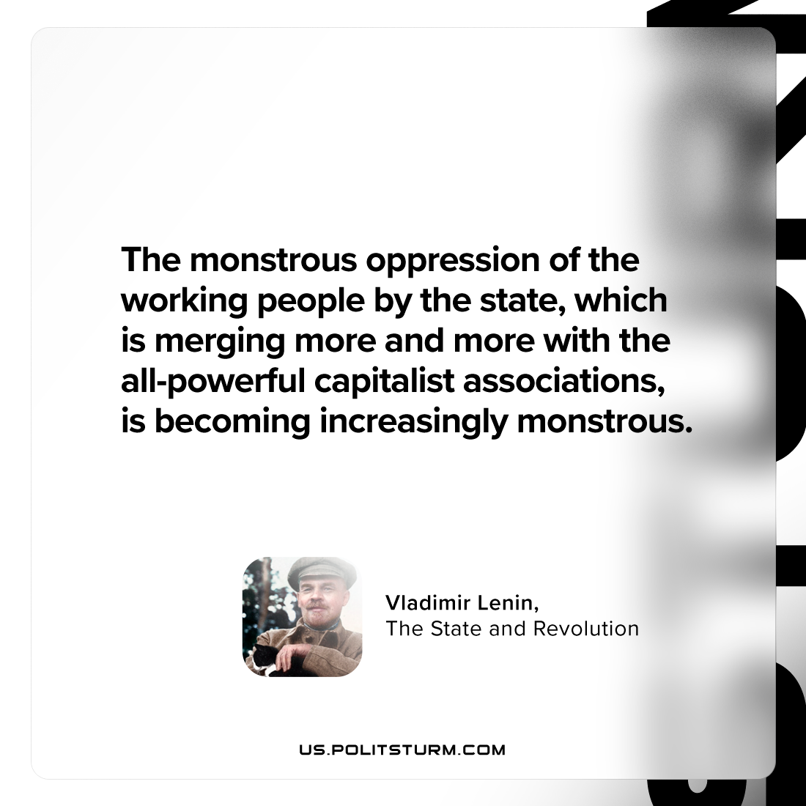

Original article
2024-03-05

"The monstrous oppression of the working people by the state, which is merging more and more with the all-powerful capitalist associations, is becoming increasingly monstrous."
Vladimir Lenin, The State and Revolution

Original article

