Lenin on the Opportunistic Center
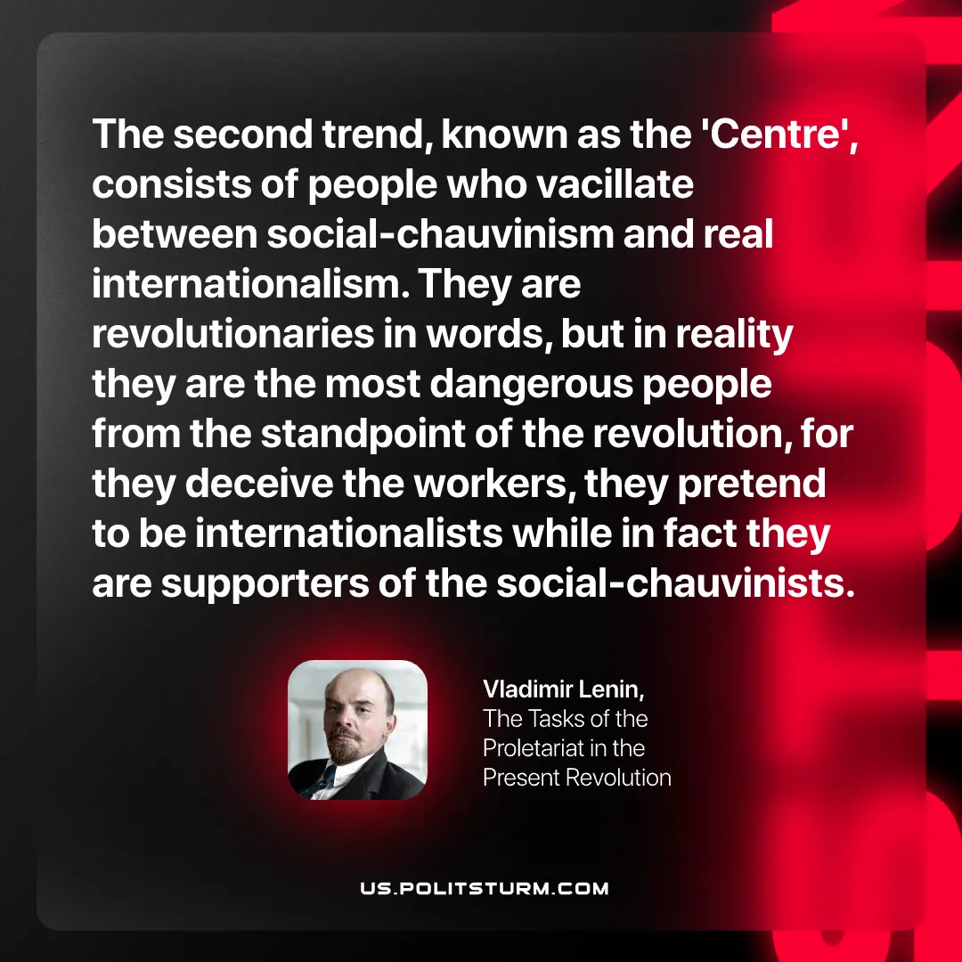

Original article
2026-06-20

The second trend, known as the 'Centre', consists of people who vacillate between social‑chauvinism and real internationalism. They are revolutionaries in words, but in reality they are the most dangerous people from the standpoint of the revolution, for they deceive the workers, they pretend to be internationalists while in fact they are supporters of the social‑chauvinists.
Vladimir Lenin, The Tasks of the Proletariat in the Present Revolution

Original article

