Lenin on the Needed Kind of Organization
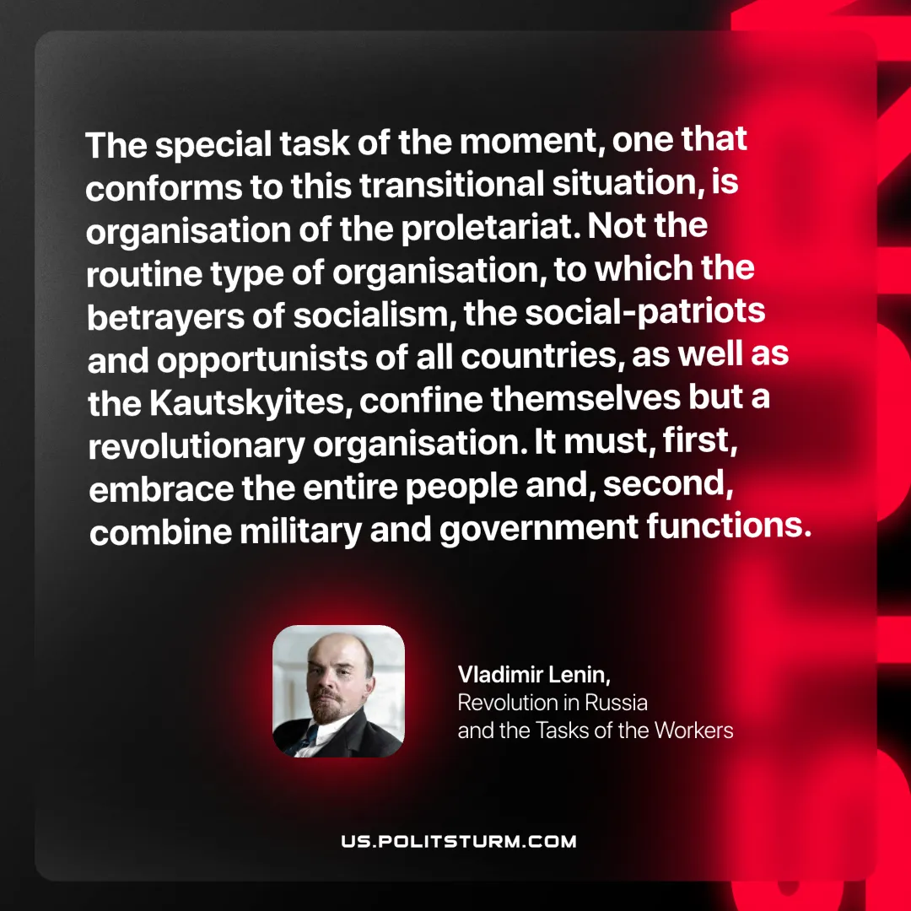

Original article
2025-07-19

“The special task of the moment, one that conforms to this transitional situation, is organisation of the proletariat. Not the routine type of organisation, to which the betrayers of socialism, the social-patriots and opportunists of all countries, as well as the Kautskyites, confine themselves but a revolutionary organisation. It must, first, embrace the entire people and, second, combine military and government functions.”
Vladimir Lenin, Revolution in Russia and the Tasks of the Workers

Original article

