Lenin on the Need for Victory and the Fear of Opportunism Towards Victory
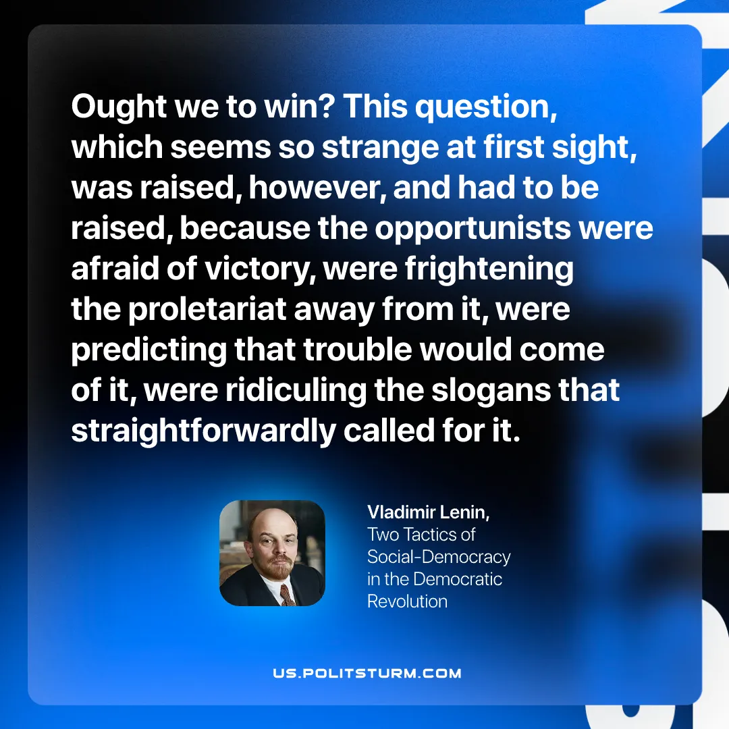

Original article
2026-03-10

“Ought we to win? This question, which seems so strange at first sight, was raised, however, and had to be raised, because the opportunists were afraid of victory, were frightening the proletariat away from it, were predicting that trouble would come of it, were ridiculing the slogans that straightforwardly called for it.”
Vladimir Lenin, Two Tactics of Social-Democracy in the Democratic Revolution

Original article

