Lenin on the Need for Clarity and Planning for an Effective Organization
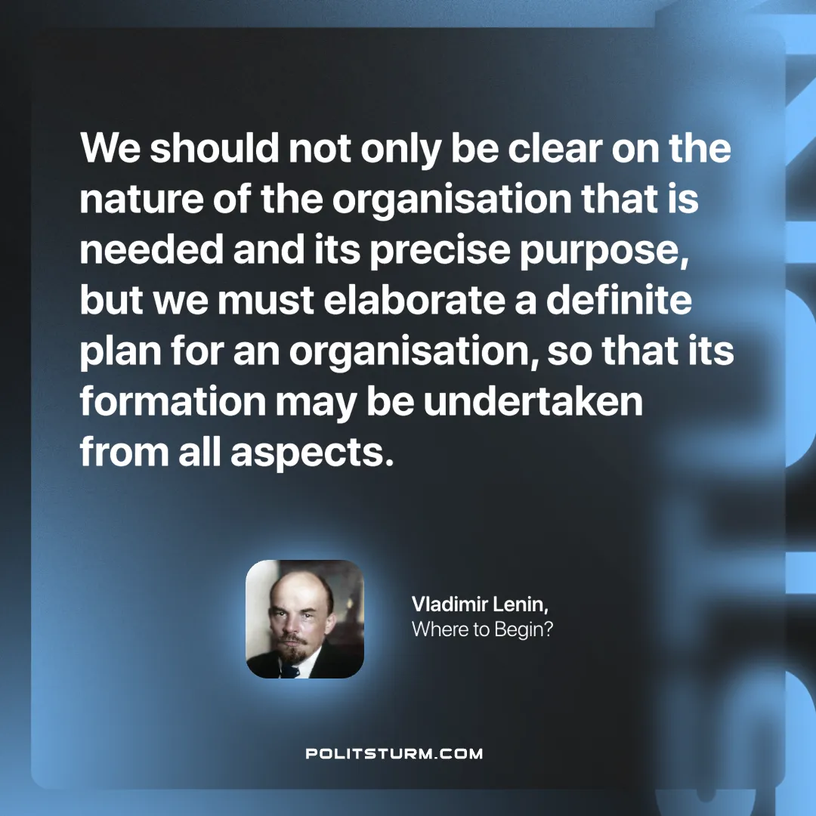

Original article
2024-12-31

“We should not only be clear on the nature of the organisation that is needed and its precise purpose, but we must elaborate a definite plan for an organisation, so that its formation may be undertaken from all aspects.”
Vladimir Lenin, Where to Begin?

Original article

