Lenin on the Need for a Revolutionary Organization
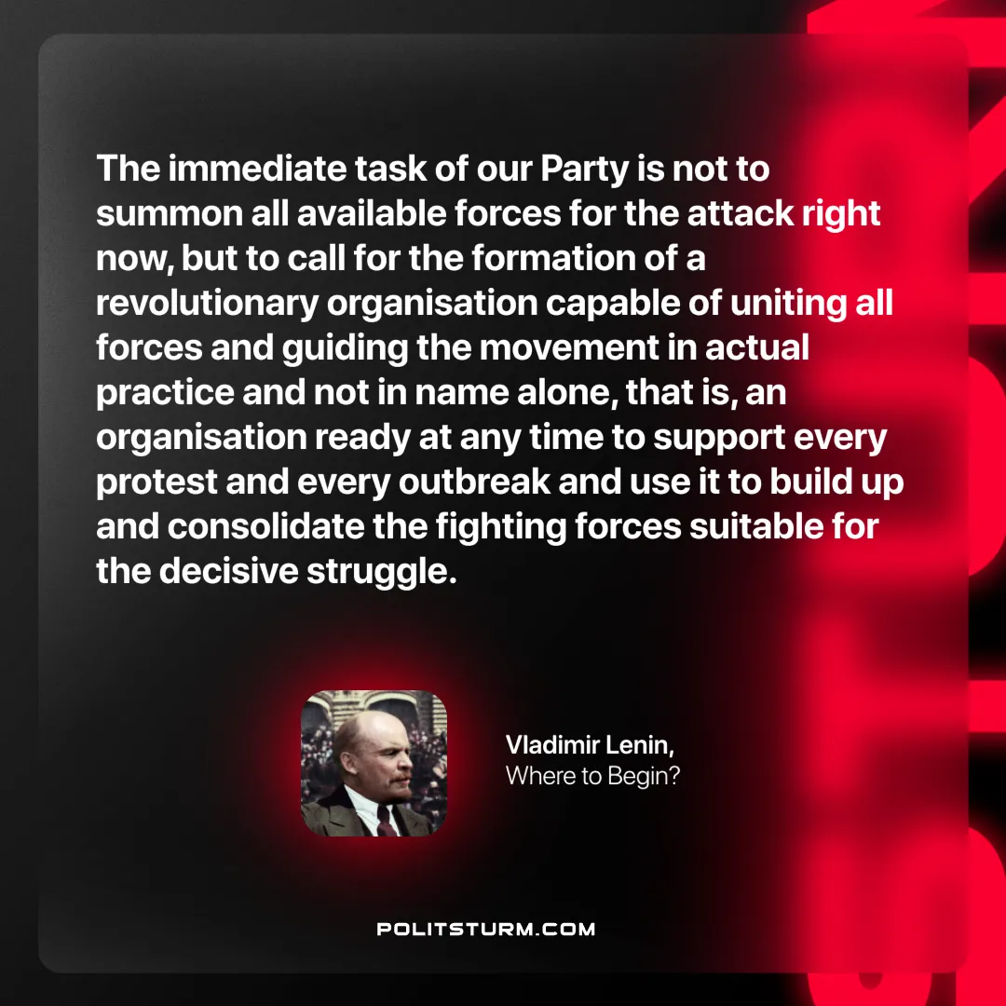

Original article
2024-10-26

“The immediate task of our Party is not to summon all available forces for the attack right now, but to call for the formation of a revolutionary organisation capable of uniting all forces and guiding the movement in actual practice and not in name alone, that is, an organisation ready at any time to support every protest and every outbreak and use it to build up and consolidate the fighting forces suitable for the decisive struggle.”
Vladimir Lenin, Where to Begin

Original article

