Lenin on the War Producing Nature of Capitalism
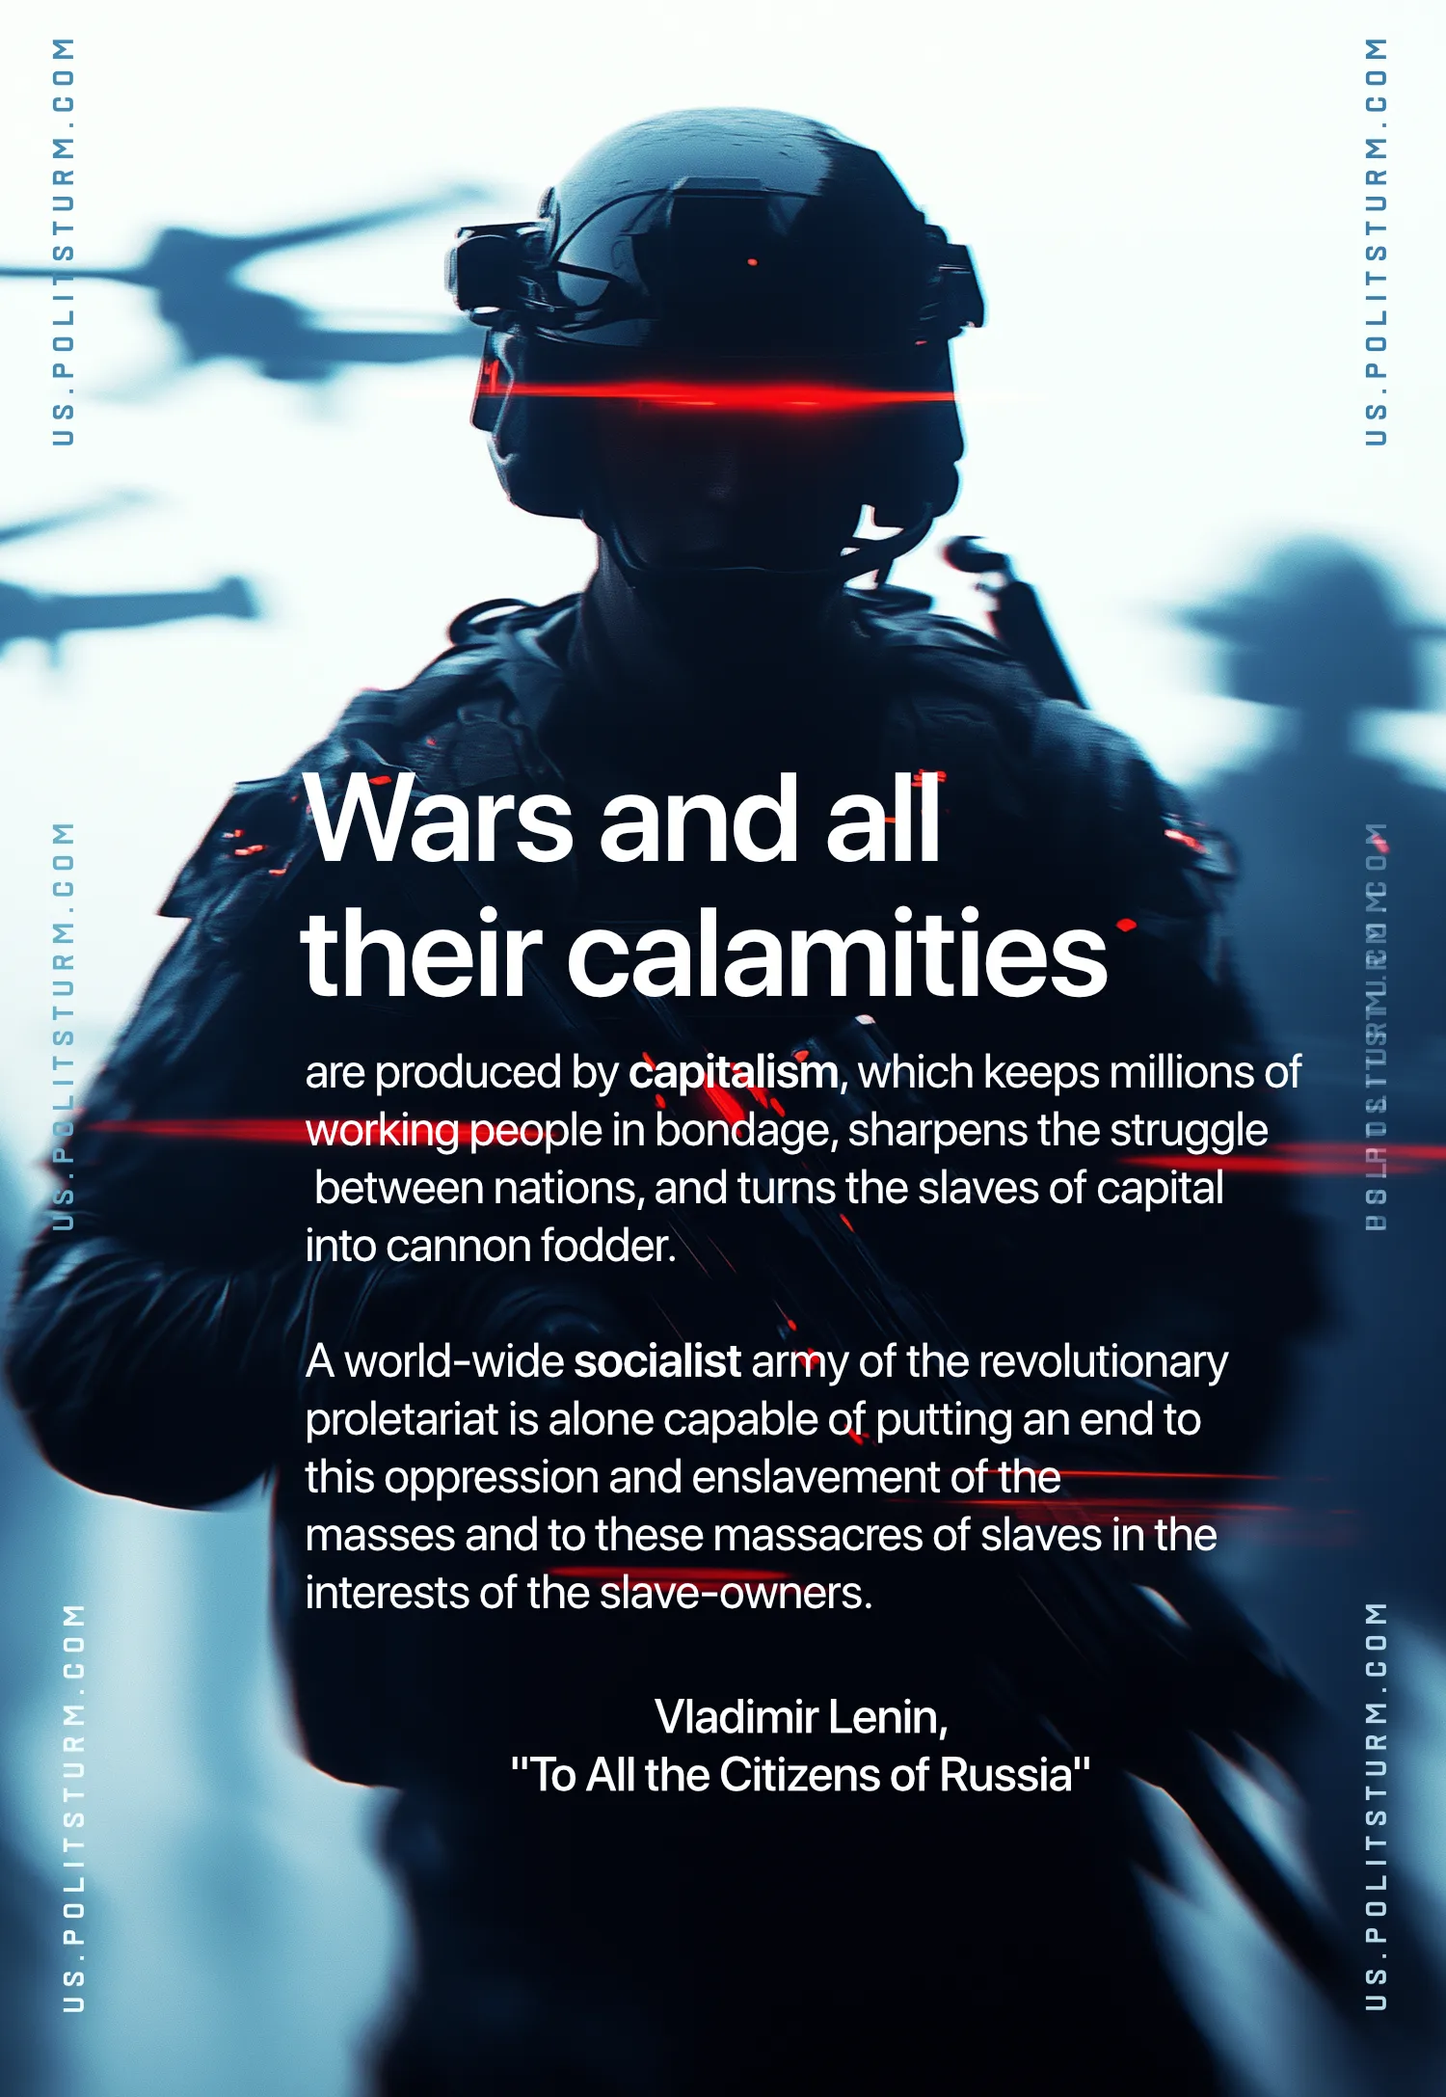

Original article
2025-02-06

“Wars and all their calamities are produced by capitalism, which keeps millions of working people in bondage, sharpens the struggle between nations, and turns the slaves of capital into cannon fodder. A world-wide socialist army of the revolutionary proletariat is alone capable of putting an end to this oppression and enslavement of the masses and to these massacres of slaves in the interests of the slave-owners.”
Vladimir Lenin, To All the Citizens of Russia

Original article

