Lenin on Unity With Opportunists Splitting the Workers
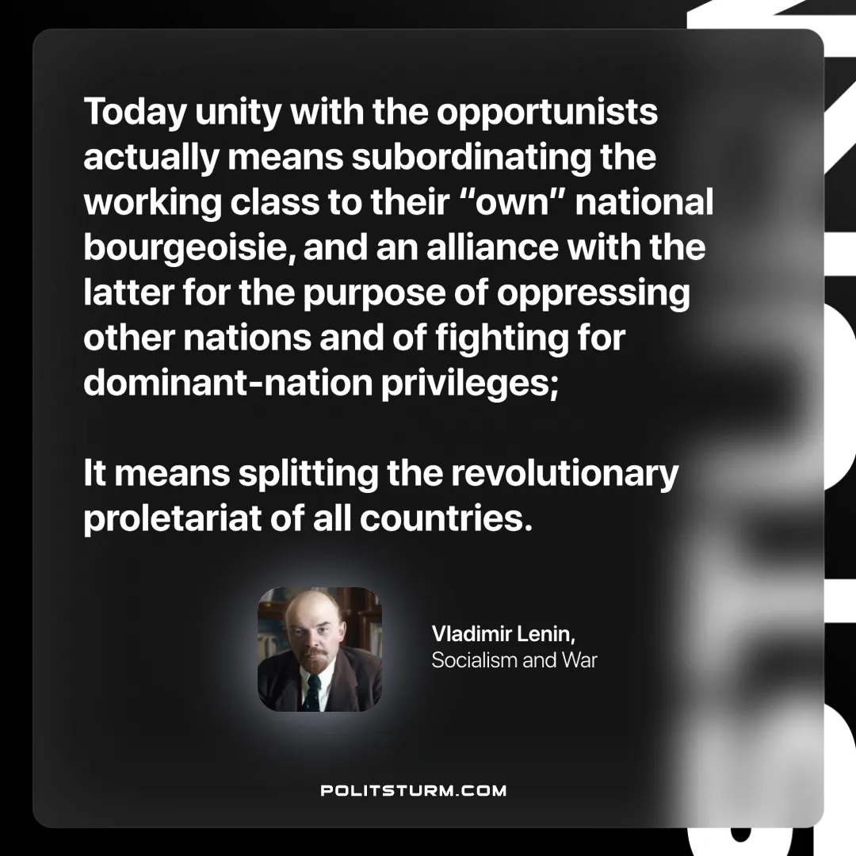

Original article
2025-04-13

“Today unity with the opportunists actually means subordinating the working class to their “own” national bourgeoisie, and an alliance with the latter for the purpose of oppressing other nations and of fighting for dominant-nation privileges; it means splitting the revolutionary proletariat of all countries.”
Vladimir Lenin, Socialism and War

Original article

