Lenin on the Nature of Capital
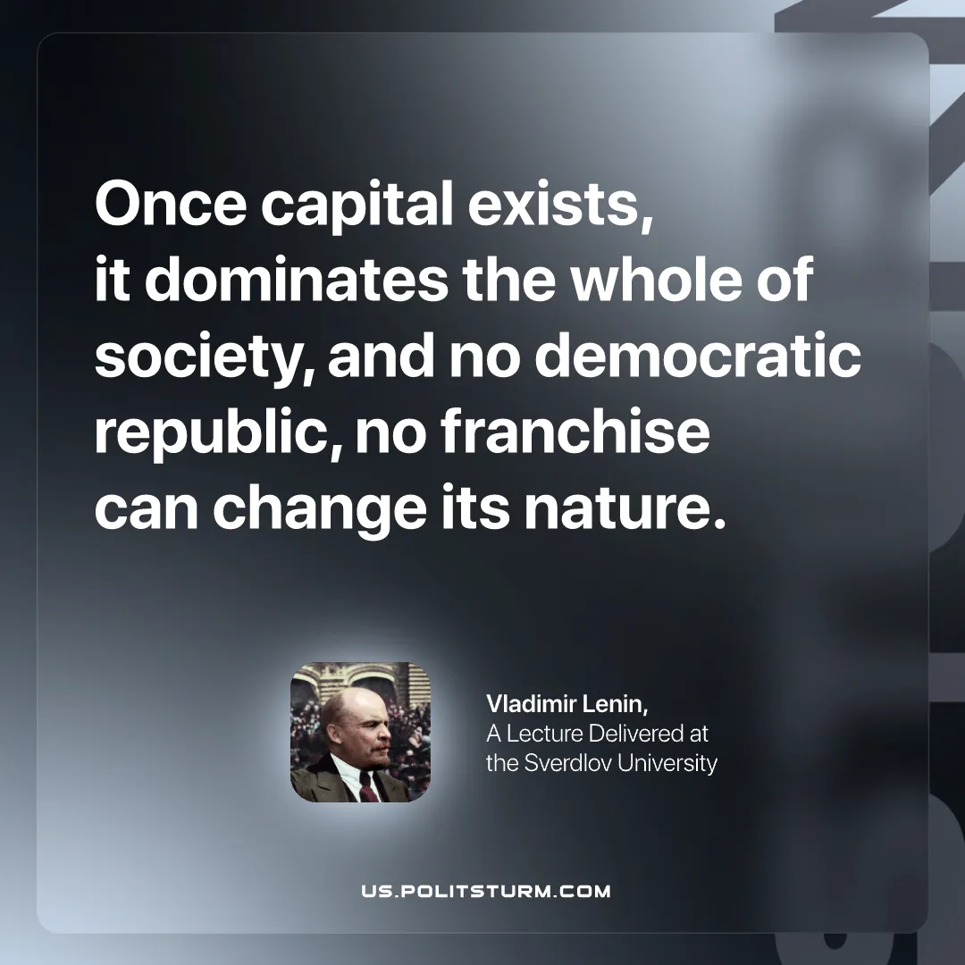

Original article
2026-02-10

“Once capital exists, it dominates the whole of society, and no democratic republic, no franchise can change its nature.”
Vladimir Lenin, A Lecture Delivered at the Sverdlov University

Original article

