Lenin on the Myth of Smooth Economic Growth
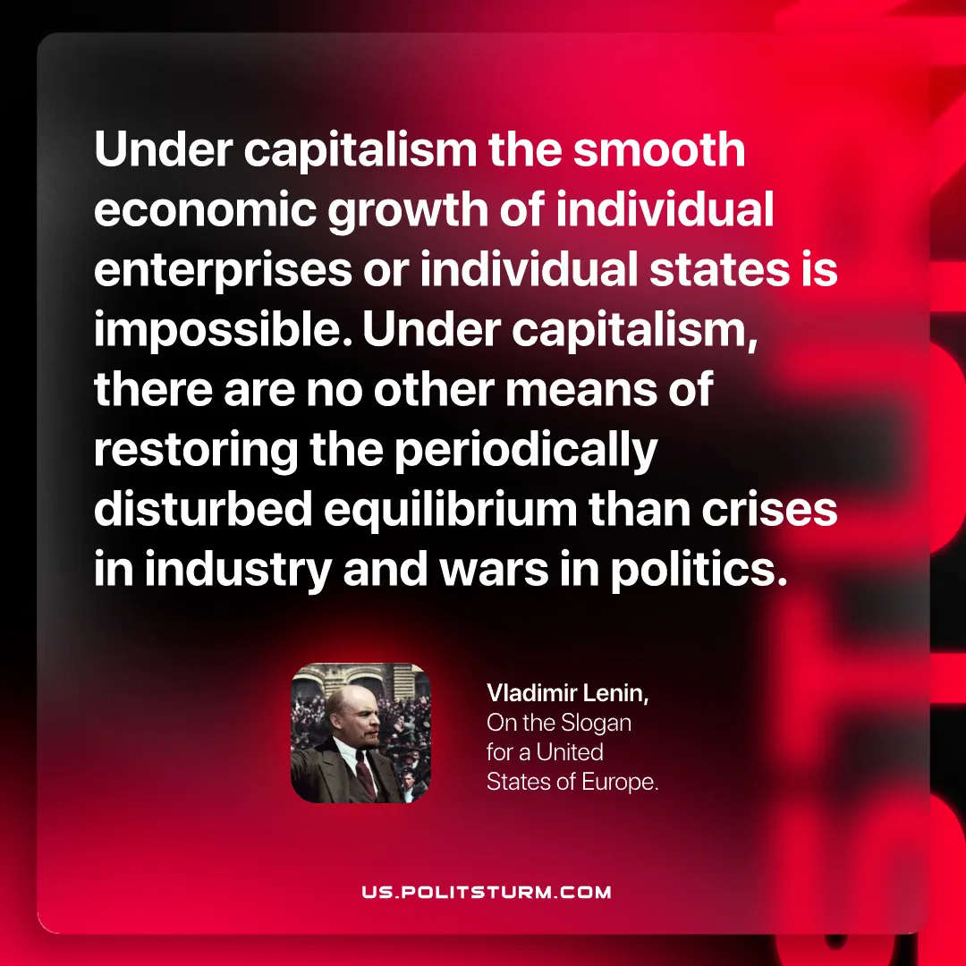

Original article
2026-07-02

Under capitalism the smooth economic growth of individual enterprises or individual states is impossible. Under capitalism, there are no other means of restoring the periodically disturbed equilibrium than crises in industry and wars in politics.
Vladimir Lenin, On the Slogan for a United States of Europe.

Original article

