Lenin on the Minority of Reactionary Workers
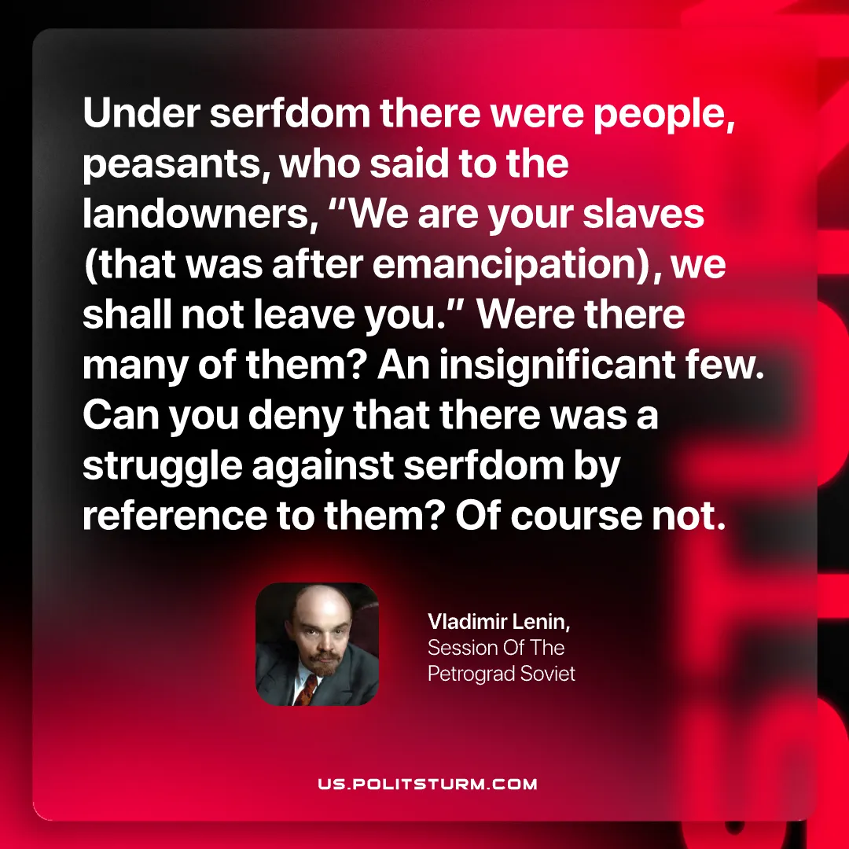

Original article
2026-10-31

Under serfdom there were people, peasants, who said to the landowners, "We are your slaves (that was after emancipation), we shall not leave you." Were there many of them? An insignificant few. Can you deny that there was a struggle against serfdom by reference to them? Of course not.
Vladimir Lenin, Session Of The Petrograd Soviet

Original article

