Lenin on the Middle Course
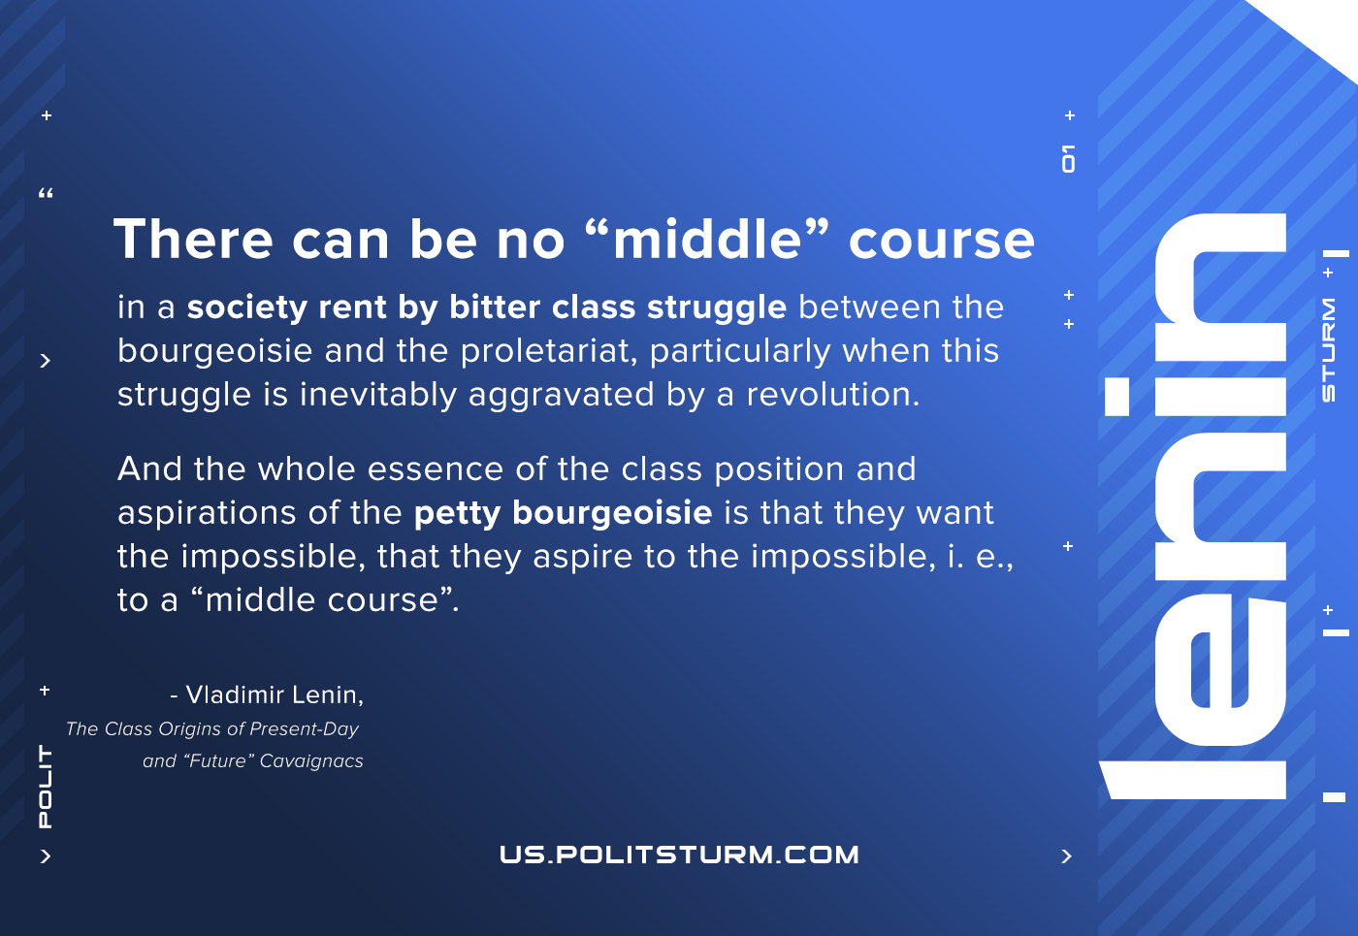

Original article
2021-07-07

There can be no “middle” course in a society rent by bitter class struggle between the bourgeoisie and the proletariat, particularly when this struggle is inevitably aggravated by a revolution. And the whole essence of the class position and aspirations of the petty bourgeoisie is that they want the impossible, that they aspire to the impossible, i. e., to a “middle course”.
Lenin, The Class Origins of Present-Day and “Future” Cavaignacs

Original article

