Lenin on the Merging of a Communist Media Outlet With the Party
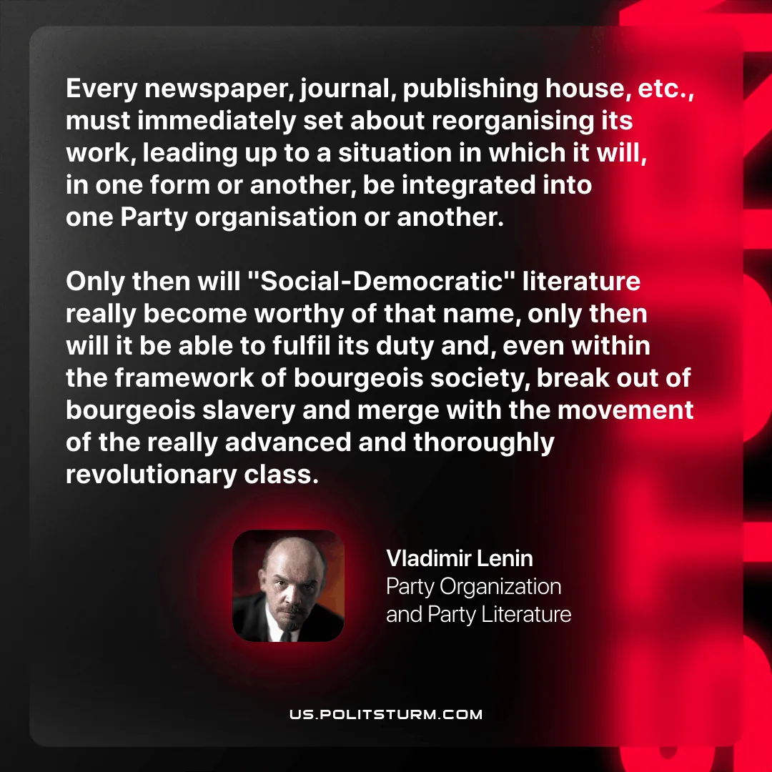

Original article
2025-11-25
1 min read

“Every newspaper, journal, publishing house, etc., must immediately set about reorganising its work, leading up to a situation in which it will, in one form or another, be integrated into one Party organisation or another. Only then will "Social-Democratic" literature really become worthy of that name, only then will it be able to fulfil its duty and, even within the framework of bourgeois society, break out of bourgeois slavery and merge with the movement of the really advanced and thoroughly revolutionary class.
Vladimir Lenin, Party Organization and Party Literature

Original article

