Lenin on the Masses
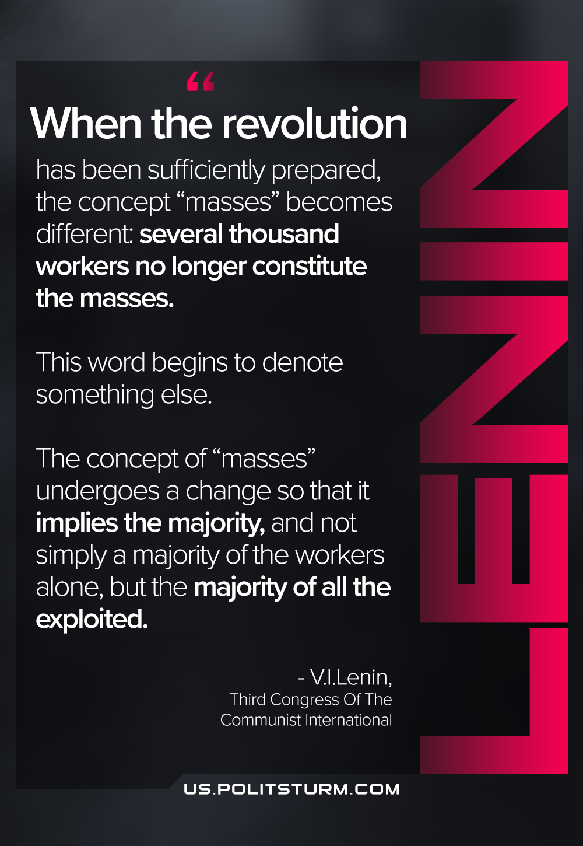

Original article
2021-06-09

When the revolution has been sufficiently prepared, the concept “masses” becomes different: several thousand workers no longer constitute the masses. This word begins to denote something else. The concept of “masses” undergoes a change so that it implies the majority, and not simply a majority of the workers alone, but the majority of all the exploited.
V. I. Lenin, Third Congress Of The Communist International

Original article

