Lenin on the Marxist Opposition to Federation and Decentralization
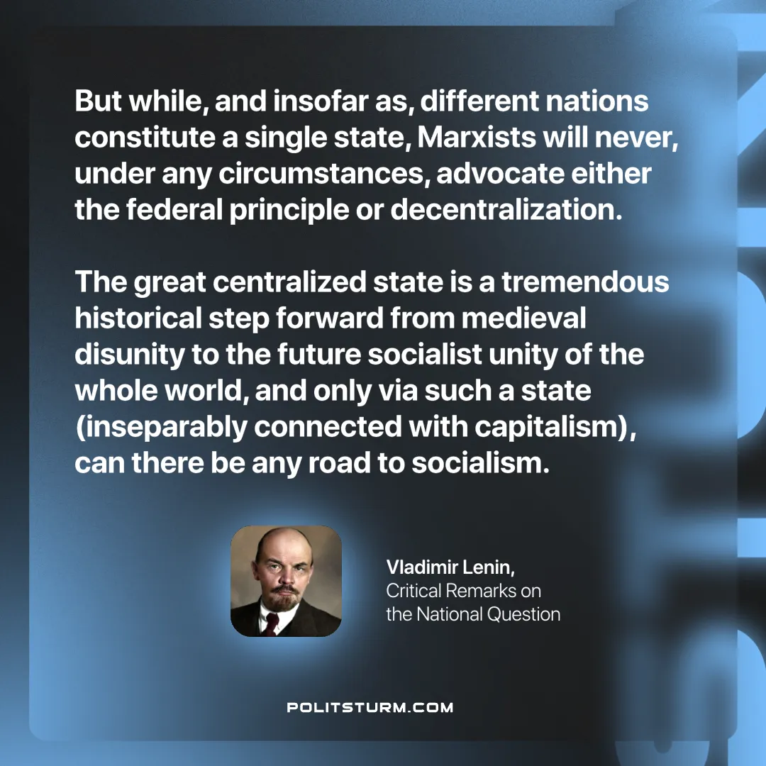

Original article
2024-12-19

“But while, and insofar as, different nations constitute a single state, Marxists will never, under any circumstances, advocate either the federal principle or decentralization. The great centralized state is a tremendous historical step forward from medieval disunity to the future socialist unity of the whole world, and only via such a state (inseparably connected with capitalism), can there be any road to socialism.”
Vladimir Lenin, Critical Remarks on the National Question

Original article

