Lenin on the Logical Conclusion of Social-Chauvinism
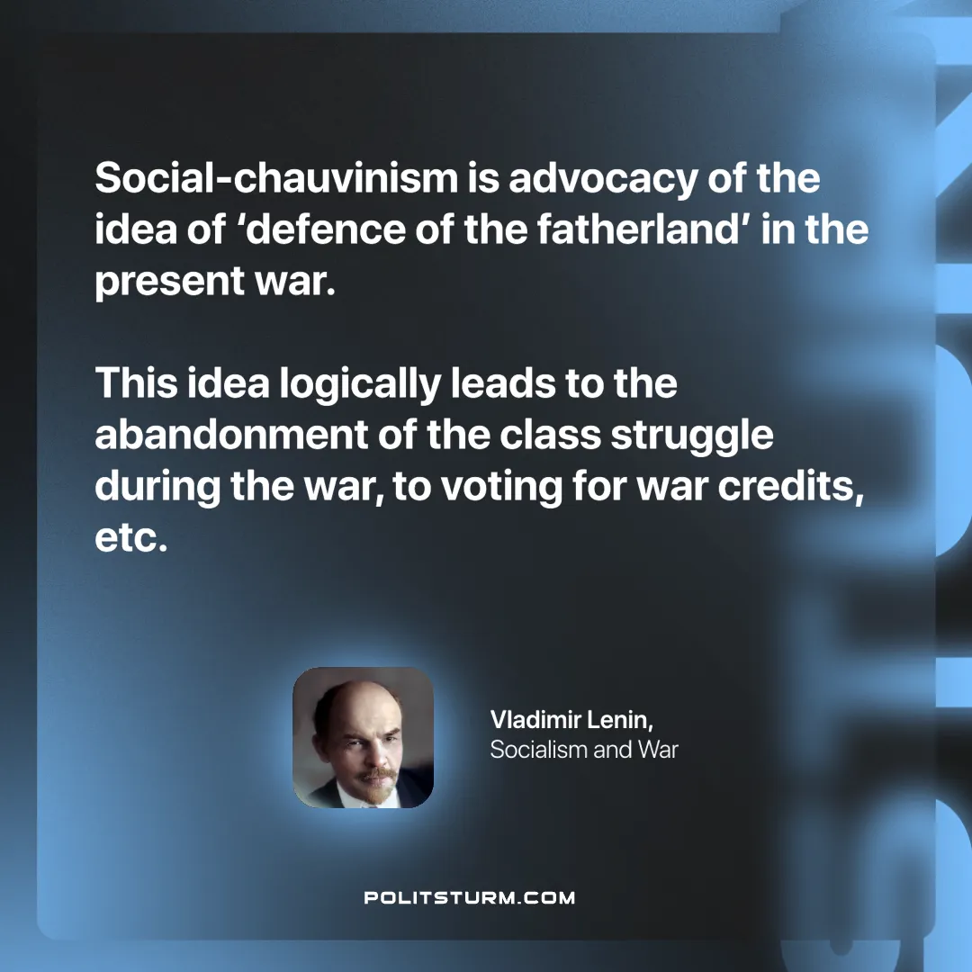

Original article
2025-04-24

“Social-chauvinism is advocacy of the idea of ‘defence of the fatherland’ in the present war. This idea logically leads to the abandonment of the class struggle during the war, to voting for war credits, etc.”
Vladimir Lenin, Socialism and War

Original article

