Lenin on the Limit Opportunists Place on Class Struggle
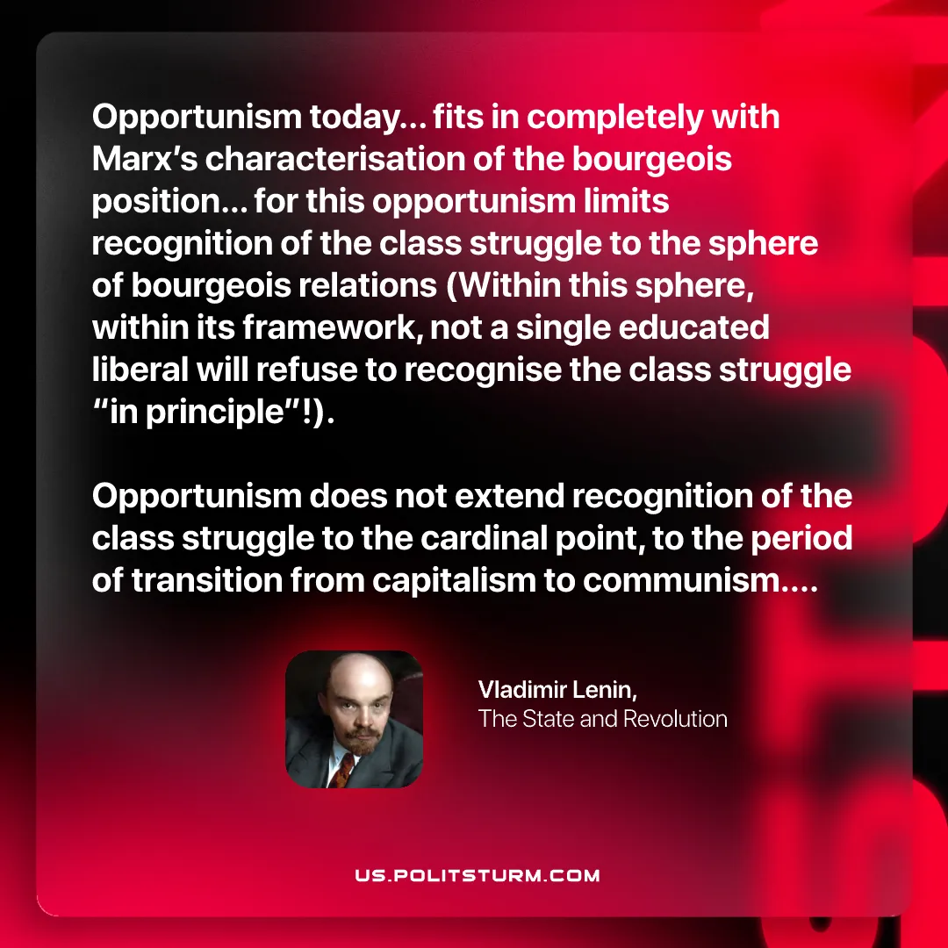

Original article
2025-09-09

“Opportunism today... fits in completely with Marx’s characterisation of the bourgeois position… for this opportunism limits recognition of the class struggle to the sphere of bourgeois relations (Within this sphere, within its framework, not a single educated liberal will refuse to recognise the class struggle “in principle”!). Opportunism does not extend recognition of the class struggle to the cardinal point, to the period of transition from capitalism to communism....”
Vladimir Lenin, The State and Revolution

Original article

