Lenin on the Irreconcilability Between Marxism and Nationalism
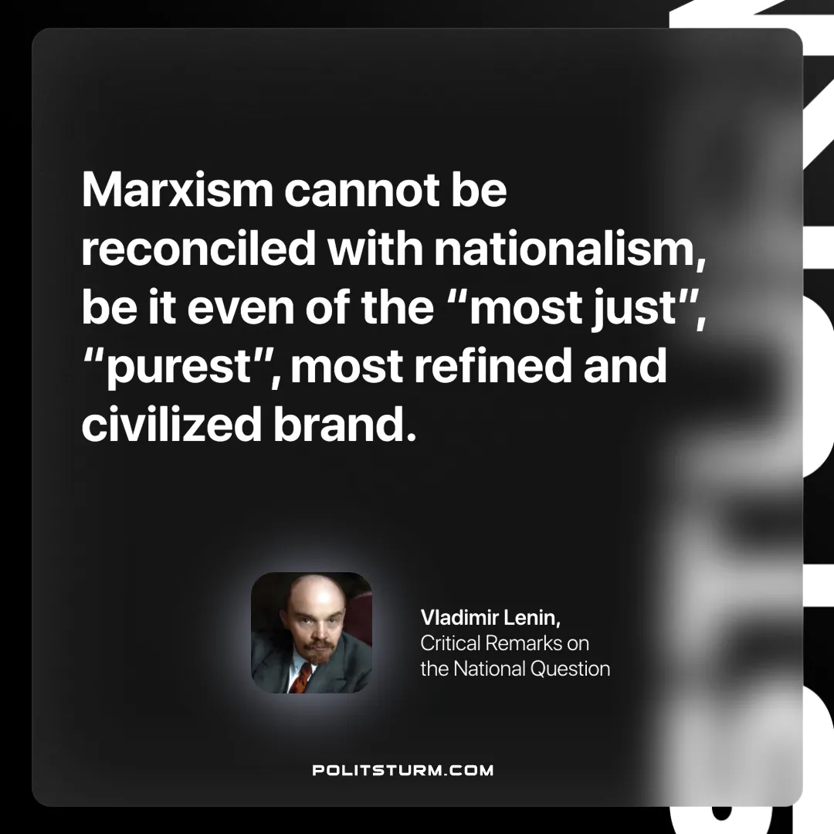

Original article
2024-10-20

“Marxism cannot be reconciled with nationalism, be it even of the “most just”, “purest”, most refined and civilized brand.”
Vladimir Lenin, Critical Remarks on the National Question

Original article

