Lenin on the Internationalist Worker's Opposition to Warmongers
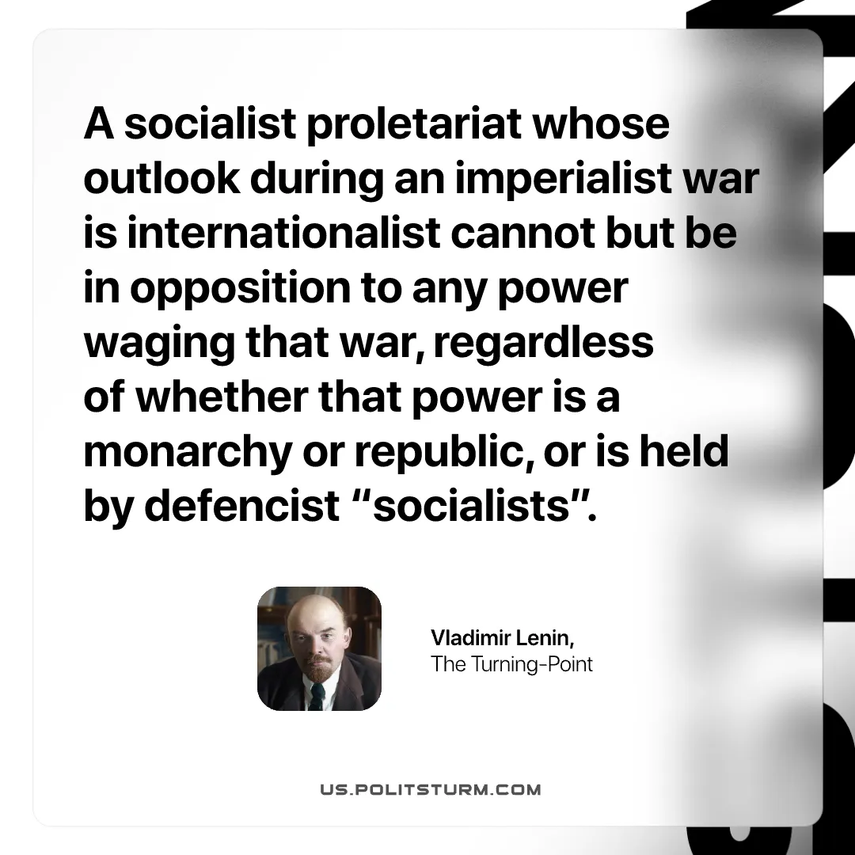

Original article
2026-03-17

“A socialist proletariat whose outlook during an imperialist war is internationalist cannot but be in opposition to any power waging that war, regardless of whether that power is a monarchy or republic, or is held by defencist “socialists”. “
Vladimir Lenin, The Turning-Point

Original article

