Lenin on the Integral Struggle against Opportunism
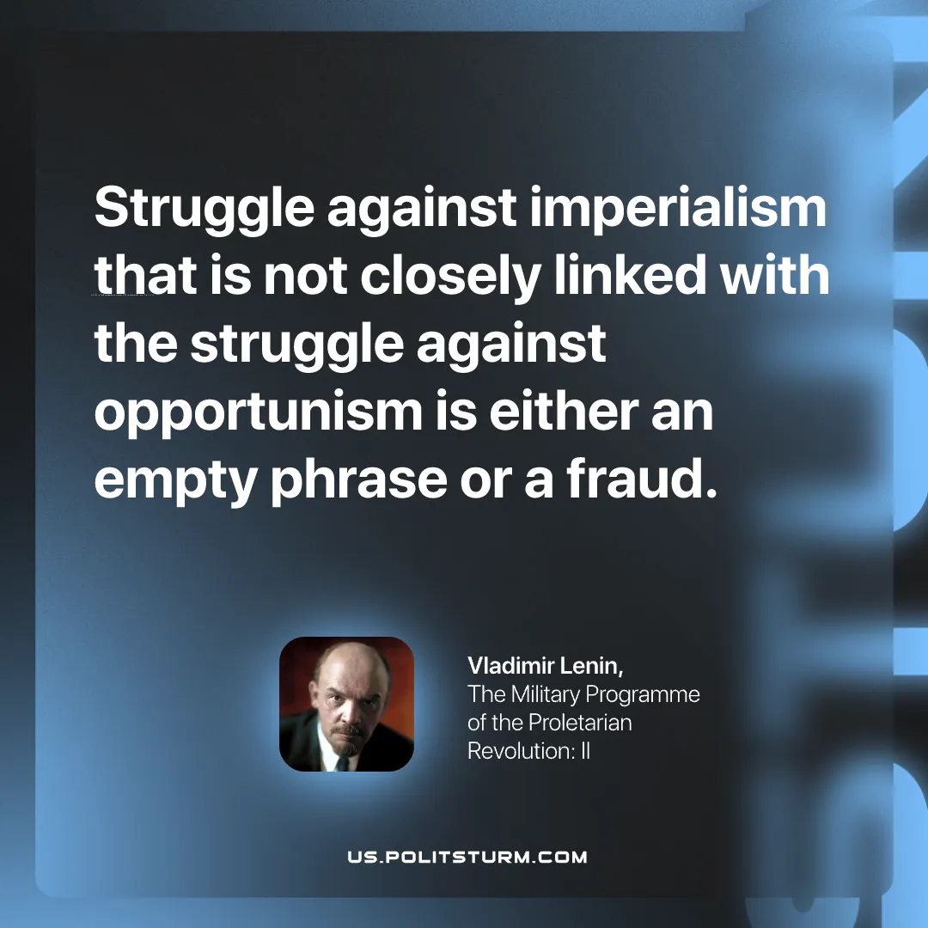

Original article
2026-11-08

Struggle against imperialism that is not closely linked with the struggle against opportunism is either an empty phrase or a fraud.
Vladimir Lenin, The Military Programme of the Proletarian Revolution: II

Original article

