Lenin on the Importance of Theory
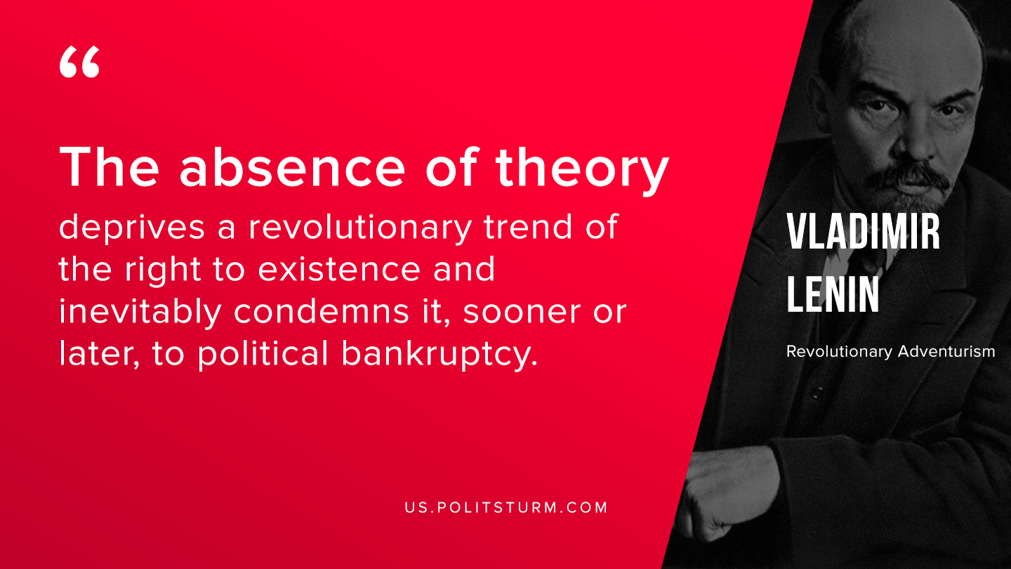

Original article
2019-11-18

The absence of theory deprives a revolutionary trend of the right to existence and inevitably condemns it, sooner or later, to political bankruptcy.
V.I. Lenin “Revolutionary Adventurism”

Original article

