Lenin on the Importance of Defining and Distinguishing Between the Left and Right Wing of the Party
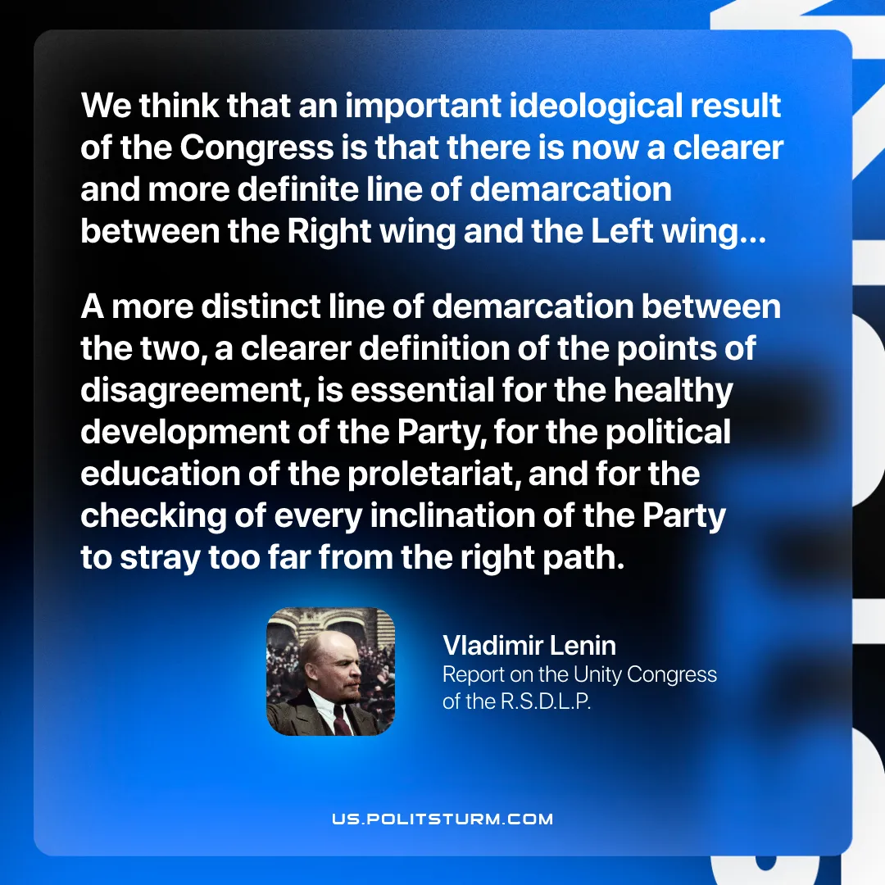

Original article
2026-01-22
1 min read

“We think that an important ideological result of the Congress is that there is now a clearer and more definite line of demarcation between the Right wing and the Left wing… A more distinct line of demarcation between the two, a clearer definition of the points of disagreement, is essential for the healthy development of the Party, for the political education of the proletariat, and for the checking of every inclination of the Party to stray too far from the right path.”
Vladimir Lenin, Report on the Unity Congress of the R.S.D.L.P.

Original article

