Lenin on the Ideological Struggle Against Religion
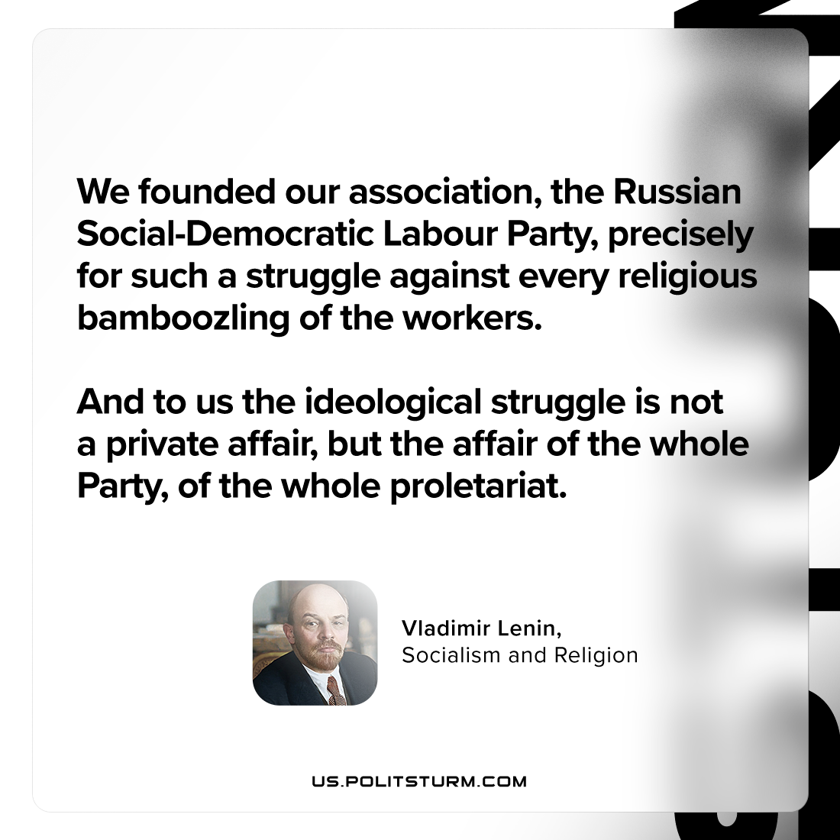

Original article
2024-05-19

"We founded our association, the Russian Social-Democratic Labour Party, precisely for such a struggle against every religious bamboozling of the workers. And to us the ideological struggle is not a private affair, but the affair of the whole Party, of the whole proletariat."
Vladimir Lenin, Socialism and Religion

Original article

