Lenin on the Hypocrisy of Bourgeois Nationalism
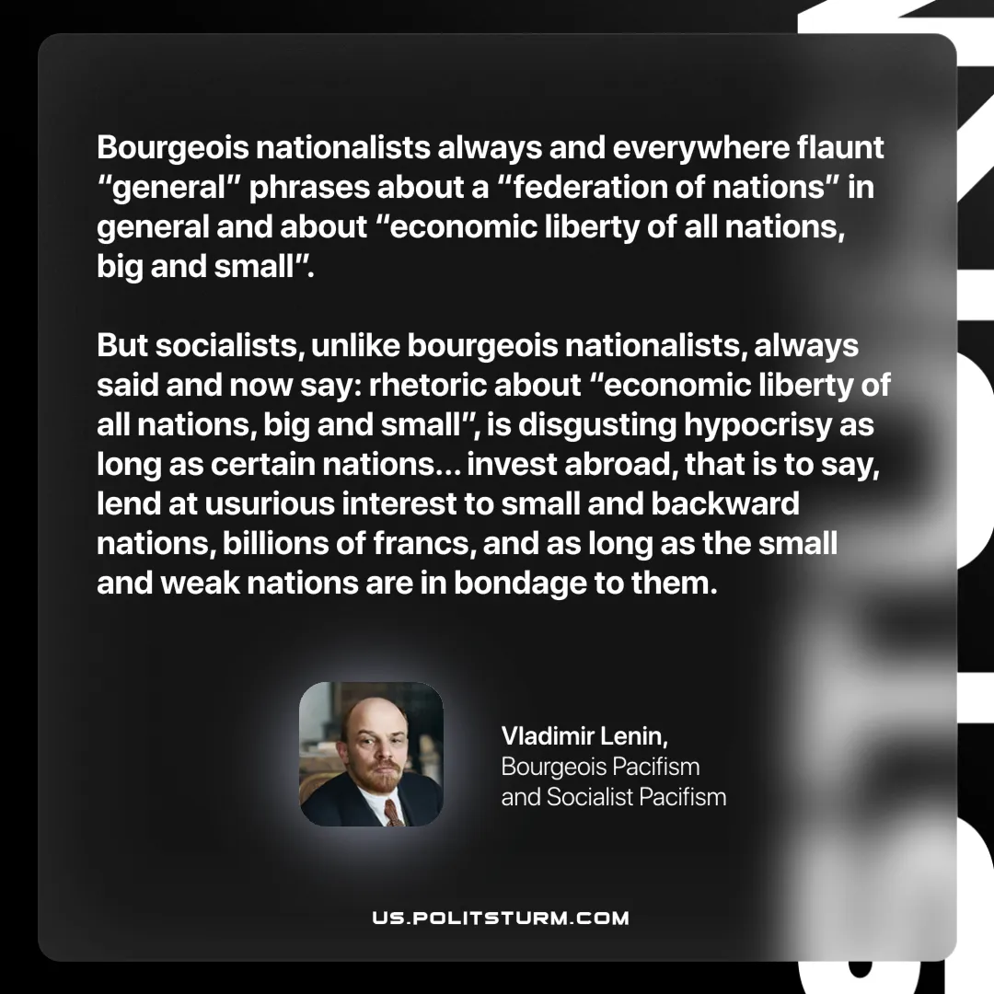

Original article
2025-07-27
1 min read

“Bourgeois nationalists always and everywhere flaunt “general” phrases about a “federation of nations” in general and about “economic liberty of all nations, big and small”. But socialists, unlike bourgeois nationalists, always said and now say: rhetoric about “economic liberty of all nations, big and small”, is disgusting hypocrisy as long as certain nations (for example, England and France) invest abroad, that is to say, lend at usurious interest to small and backward nations, billions of francs, and as long as the small and weak nations are in bondage to them.”
Vladimir Lenin, Bourgeois Pacifism and Socialist Pacifism

Original article

