Lenin on the Harm From Masked Opportunists
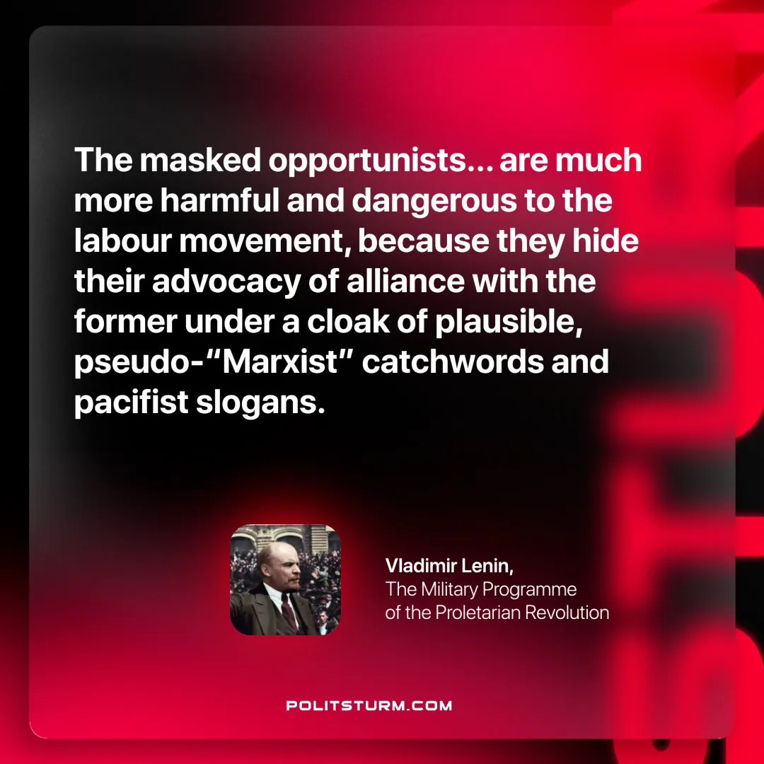

Original article
2025-06-14

“The masked opportunists… are much more harmful and dangerous to the labour movement, because they hide their advocacy of alliance with the former under a cloak of plausible, pseudo-“Marxist” catchwords and pacifist slogans.”
Vladimir Lenin, The Military Programme of the Proletarian Revolution

Original article

