Lenin on the Growth of Monopolies
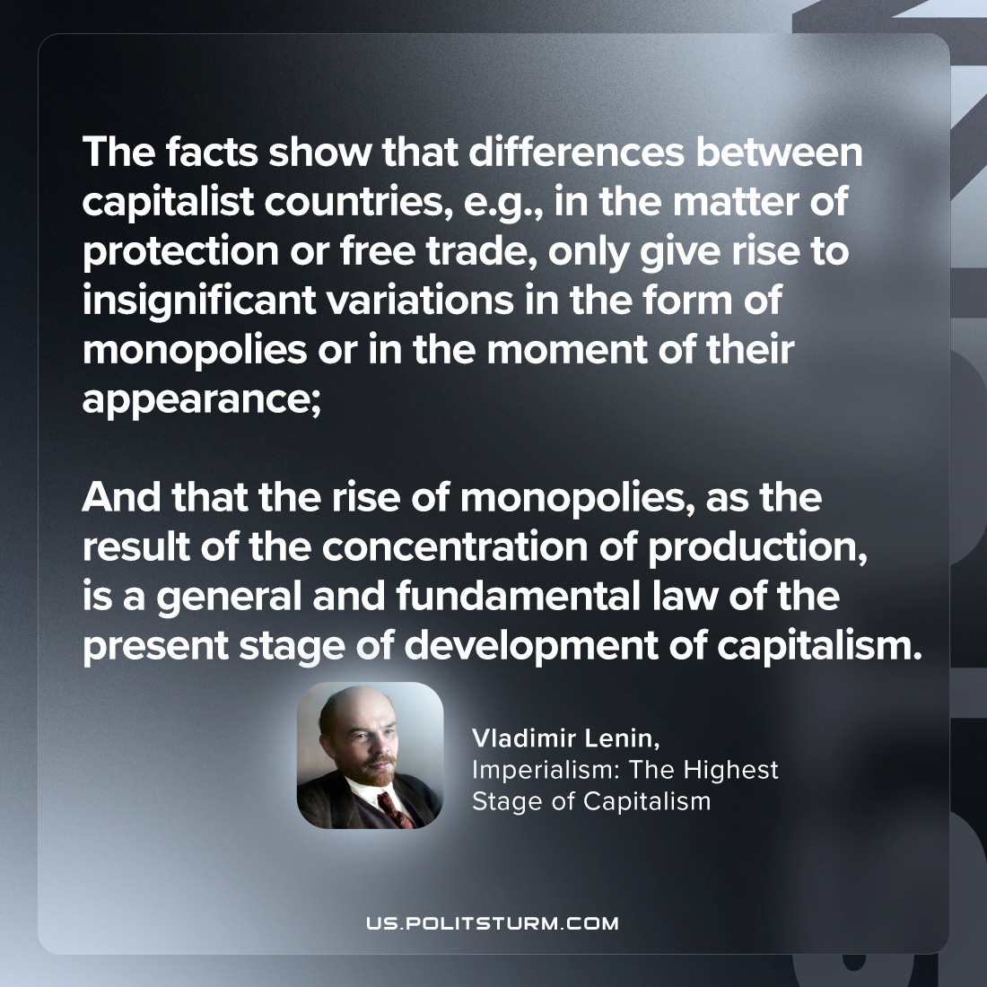

Original article
2023-09-24

"The facts show that differences between capitalist countries, e.g., in the matter of protection or free trade, only give rise to insignificant variations in the form of monopolies or in the moment of their appearance; and that the rise of monopolies, as the result of the concentration of production, is a general and fundamental law of the present stage of development of capitalism."
Vladimir Lenin, Imperialism: the Highest Stage of Capitalism

Original article

