Lenin on the Growth of Capitalism
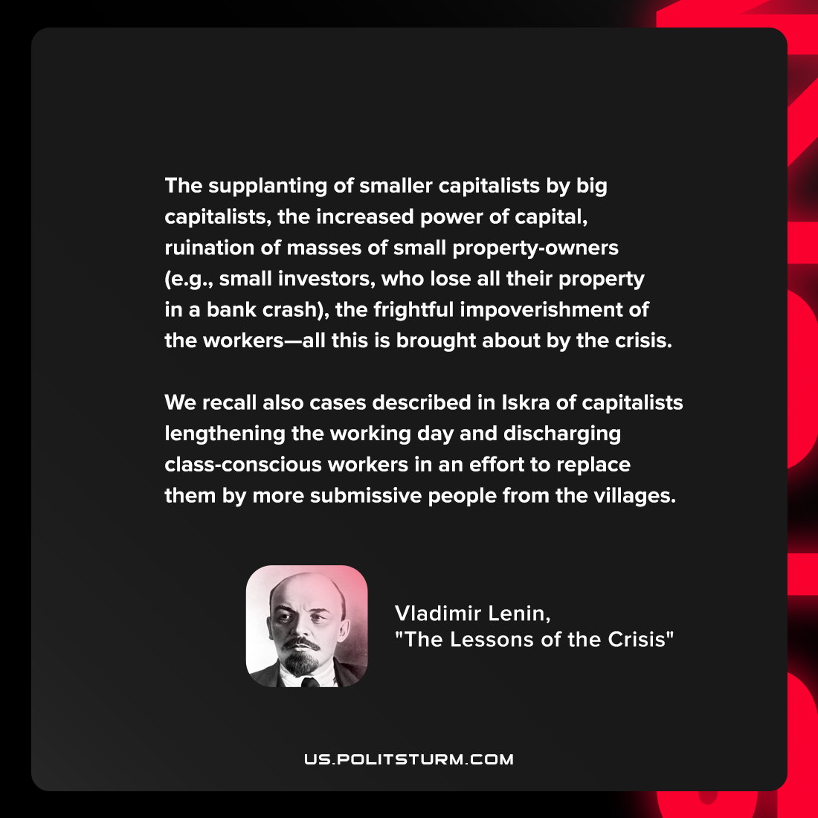

Original article
2022-05-22

The supplanting of smaller capitalists by big capitalists, the increased power of capital, ruination of masses of small property-owners (e.g., small investors, who lose all their property in a bank crash), the frightful impoverishment of the workers—all this is brought about by the crisis. We recall also cases described in Iskra of capitalists lengthening the working day and discharging class-conscious workers in an effort to replace them by more submissive people from the villages.

Vladimir Lenin, “The Lessons of the Crisis”

Original article

