Lenin on the Government and Protests
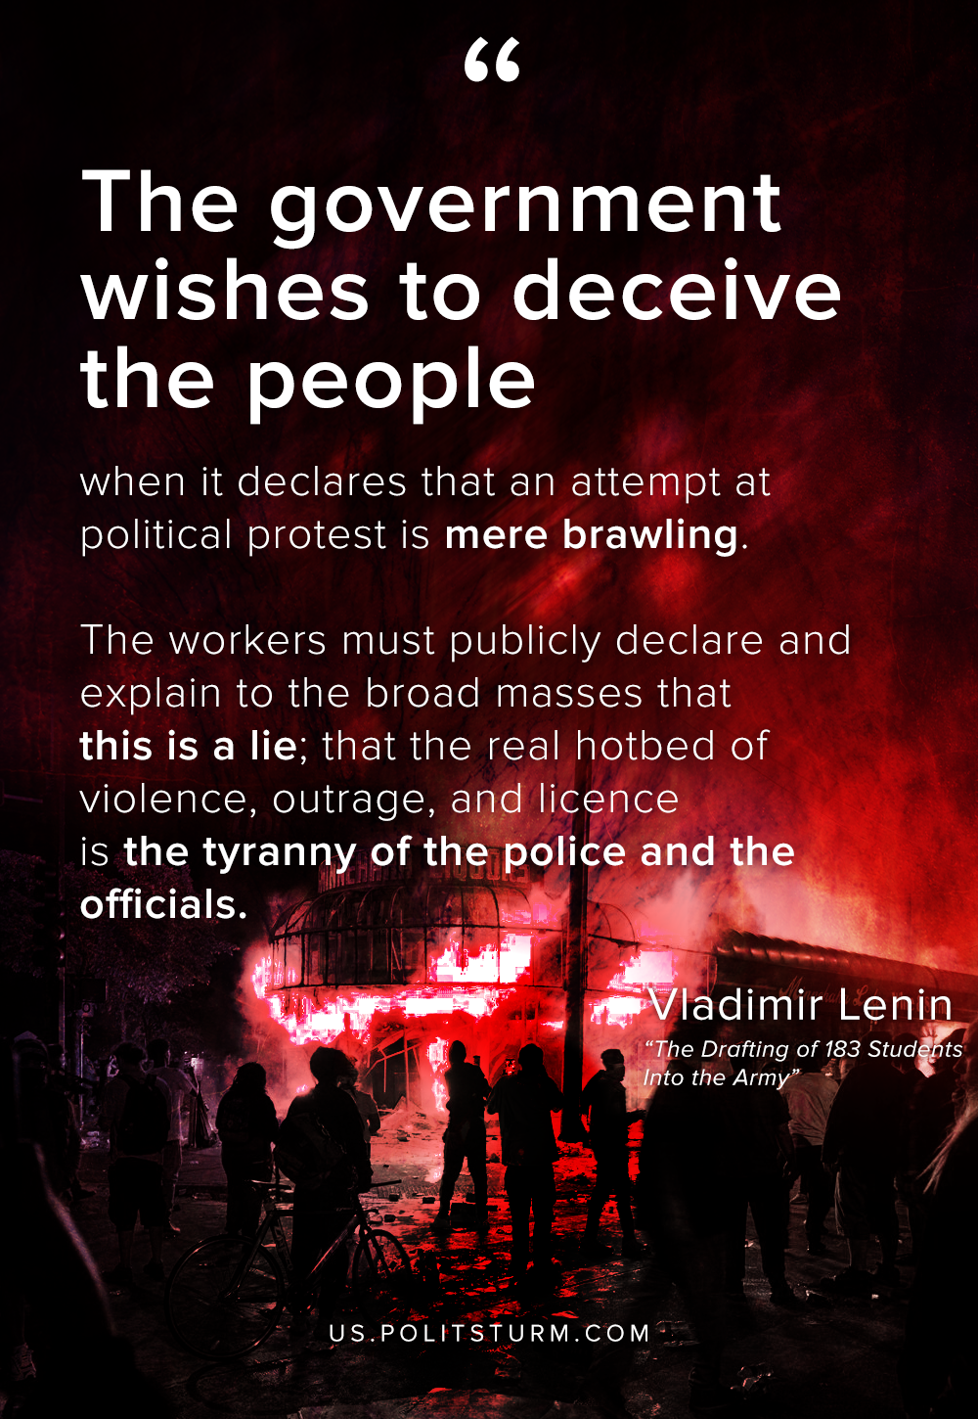

Original article
2020-05-31

The government wishes to deceive the people when it declares that an attempt at political protest is mere brawling.
The workers must publicly declare and explain to the broad masses that this is a lie; that the real hotbed of violence, outrage, and licence is the tyranny of the police and the officials.
Vladimir Lenin, The Drafting of 183 Students Into the Army

Original article

