Lenin on the Future of Humanity
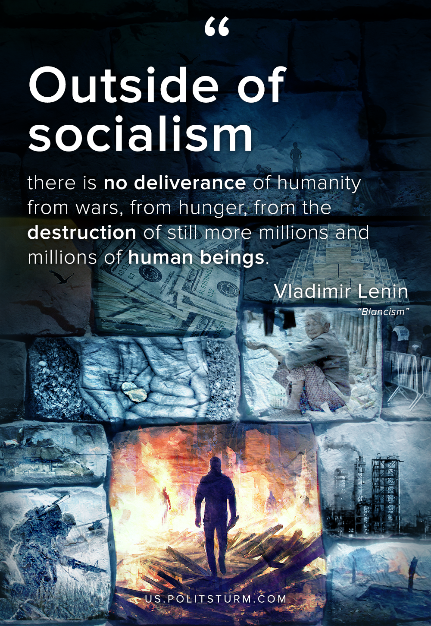

Original article
2020-04-24

Outside of socialism there is no deliverance of humanity from wars, from hunger, from the destruction of still more millions and millions of human beings.
Vladimir Lenin, “Blancism”.

Original article

