Lenin on the Fraternal Alliance
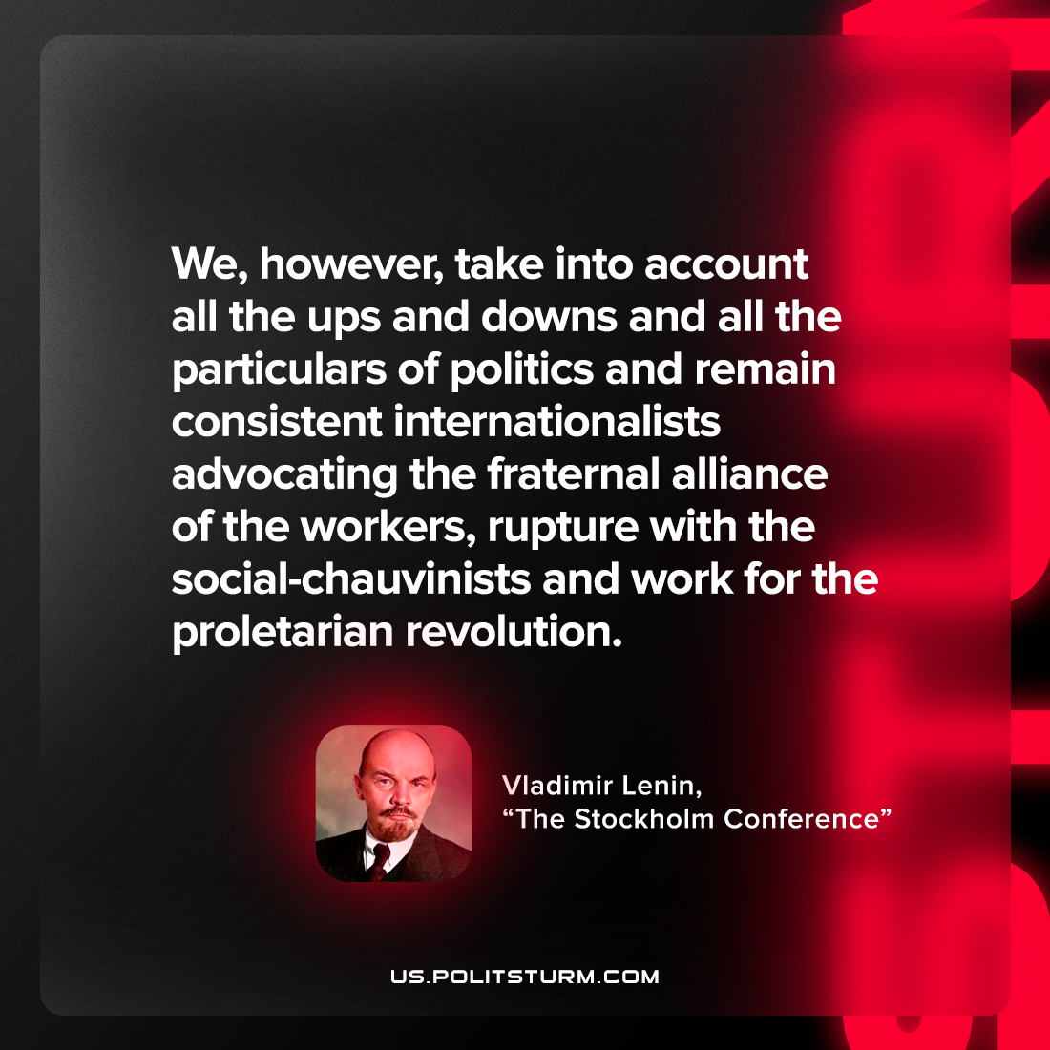

Original article
2022-08-22

We, however, take into account all the ups and downs and all the particulars of politics and remain consistent internationalists advocating the fraternal alliance of the workers, rupture with the social-chauvinists and work for the proletarian revolution.

Vladimir Lenin, “The Stockholm Conference”

Original article

