Lenin on the Fog of Religion
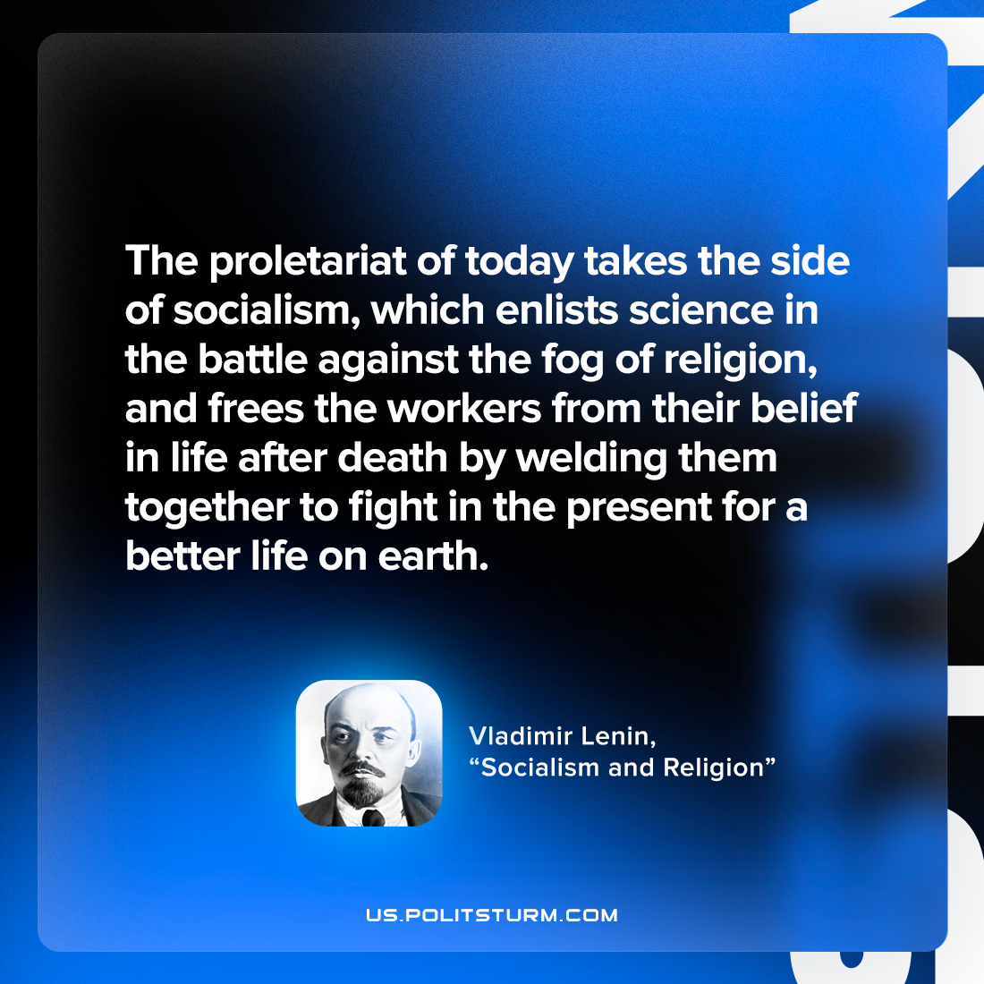

Original article
2022-07-17

The proletariat of today takes the side of socialism, which enlists science in the battle against the fog of religion, and frees the workers from their belief in life after death by welding them together to fight in the present for a better life on earth.

Vladimir Lenin, “Socialism and religion”

Original article

