Lenin on the Fight for Truth
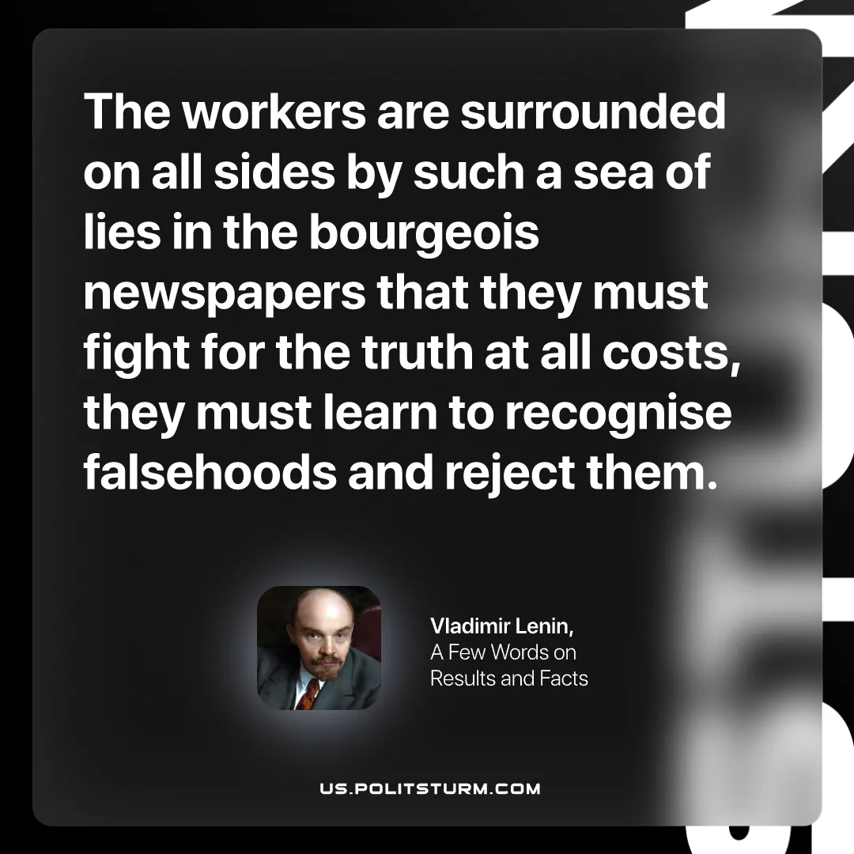

Original article
2026-10-03

The workers are surrounded on all sides by such a sea of lies in the bourgeois newspapers that they must fight for the truth at all costs, they must learn to recognise falsehoods and reject them.
Vladimir Lenin, A Few Words on Results and Facts

Original article

