Lenin on the Fierce Competition of Capitalism
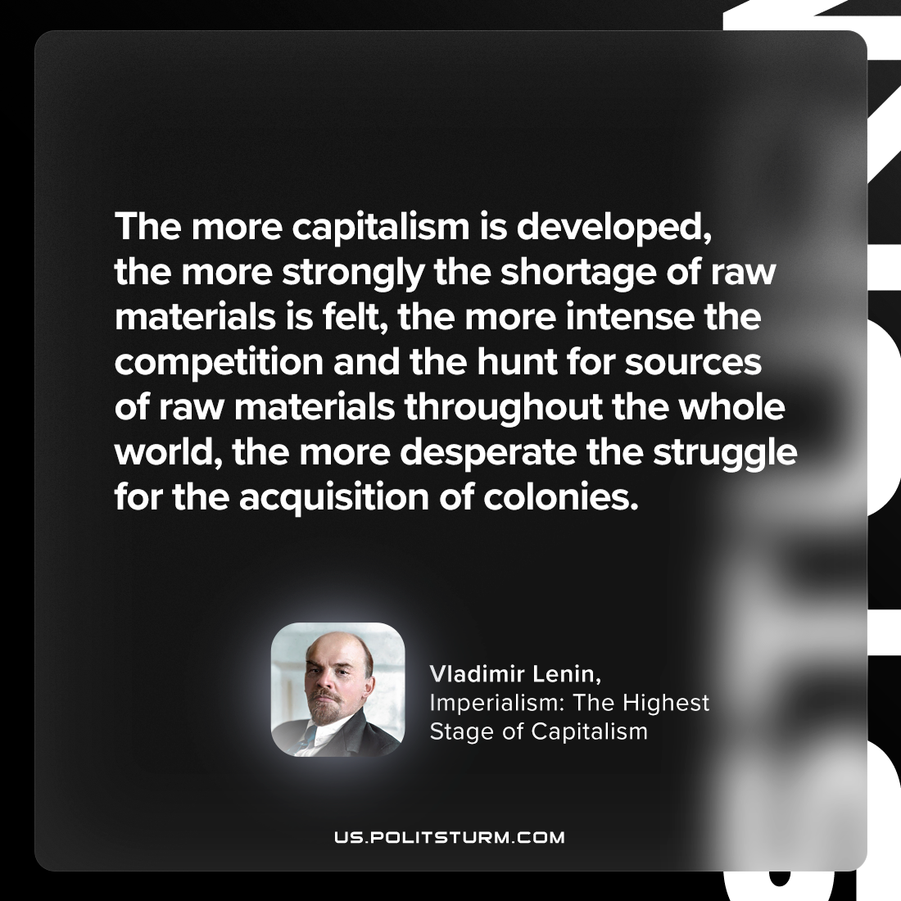

Original article
2023-11-18

"The more capitalism is developed, the more strongly the shortage of raw materials is felt, the more intense the competition and the hunt for sources of raw materials throughout the whole world, the more desperate the struggle for the acquisition of colonies."
Vladimir Lenin, Imperialism: the Highest Stage of Capitalism

Original article

