Lenin on the Fate of the Small Owner
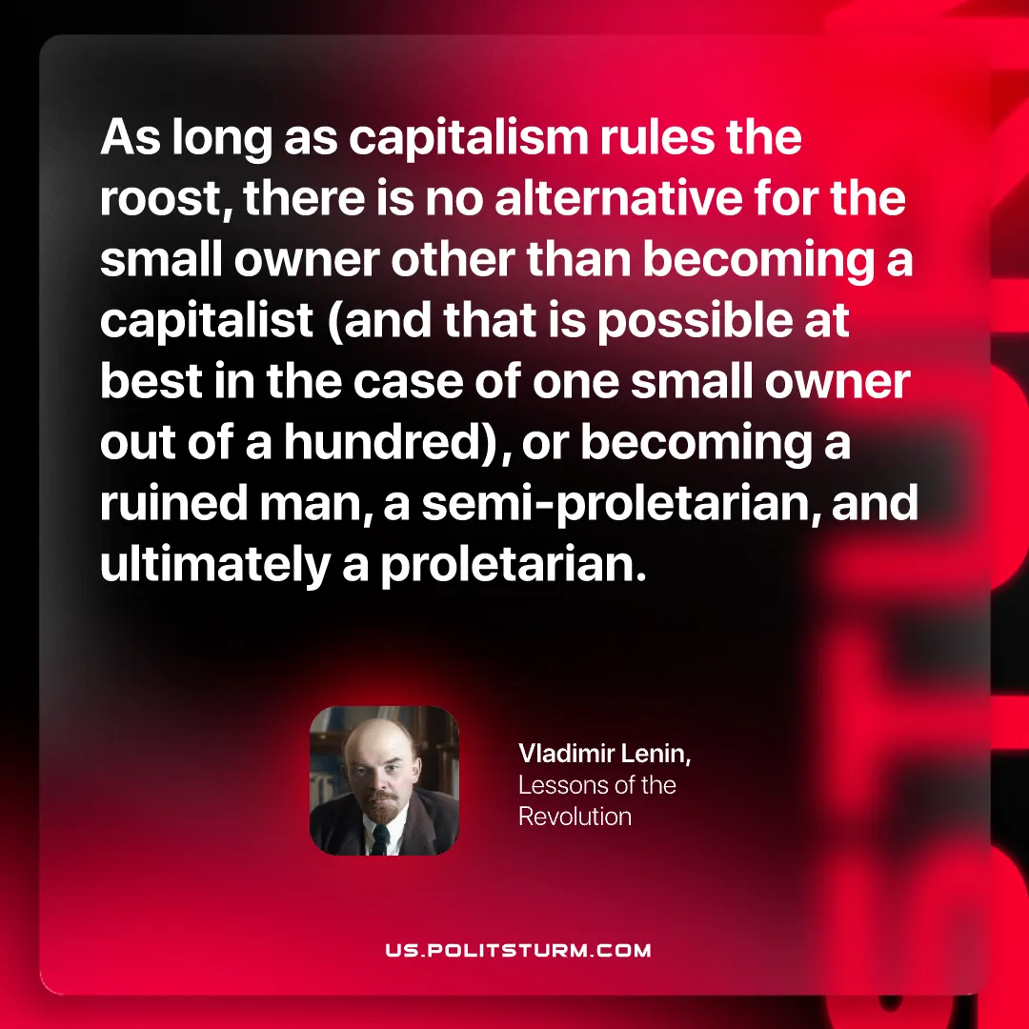

Original article
2026-10-22

As long as capitalism rules the roost, there is no alternative for the small owner other than becoming a capitalist (and that is possible at best in the case of one small owner out of a hundred), or becoming a ruined man, a semi-proletarian, and ultimately a proletarian.
Vladimir Lenin, Lessons of the Revolution

Original article

