Lenin on the Export of Capital and Development of Capitalism
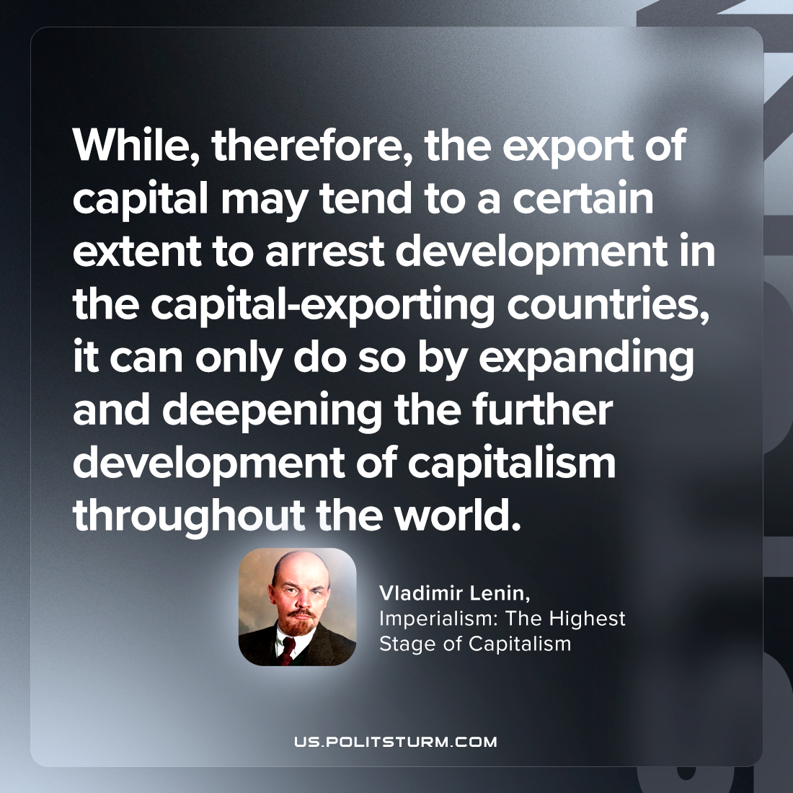

Original article
2023-11-09

"While, therefore, the export of capital may tend to a certain extent to arrest development in the capital-exporting countries, it can only do so by expanding and deepening the further development of capitalism throughout the world."
Vladimir Lenin, Imperialism: the Highest Stage of Capitalism

Original article

