Lenin on the Export of Capital
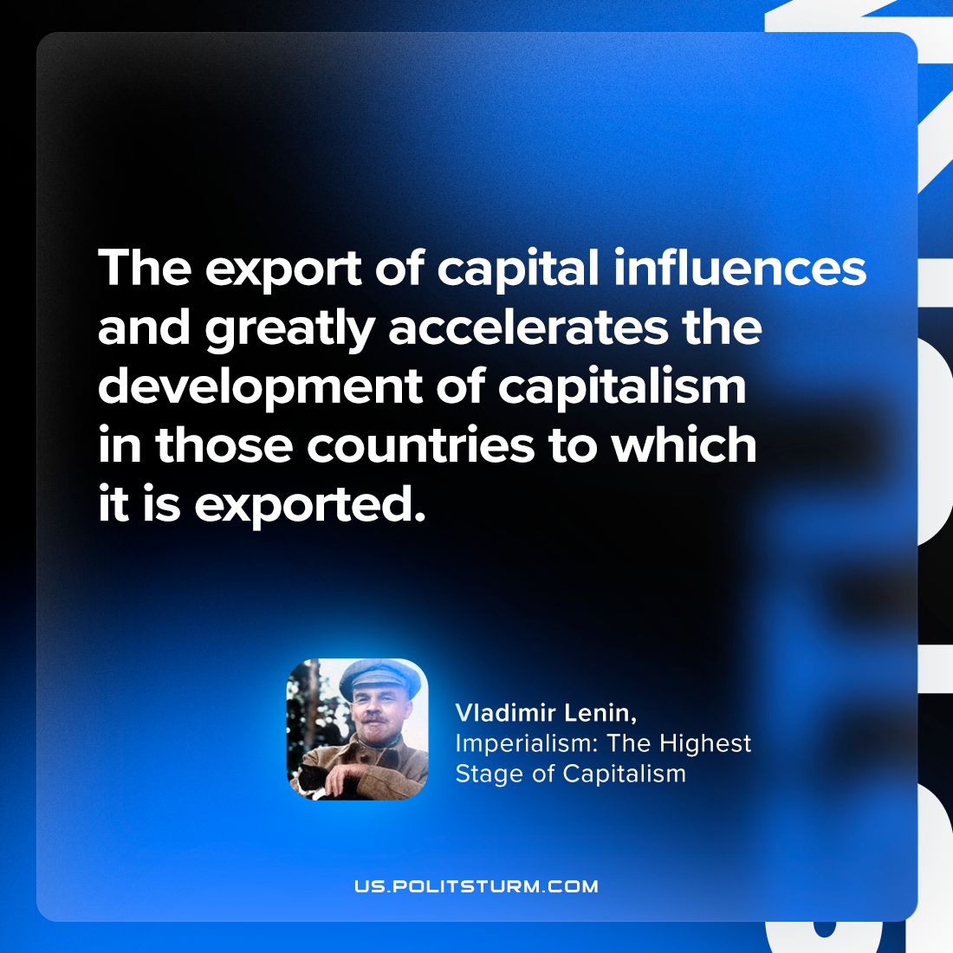

Original article
2023-11-07

"The export of capital influences and greatly accelerates the development of capitalism in those countries to which it is exported."
Vladimir Lenin, Imperialism: the Highest Stage of Capitalism

Original article

