Lenin on the Experience of Mass Struggle
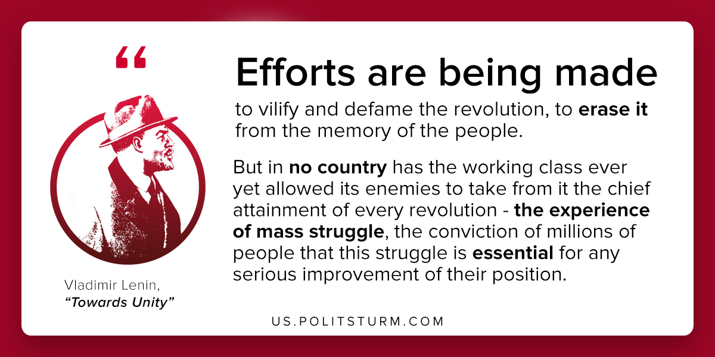

Original article
2020-04-14
1 min read

The revolutionaries are being harassed, tortured and exterminated as never before. Efforts are being made to vilify and defame the revolution, to erase it from the memory of the people.
But in no country has the working class ever yet allowed its enemies to take from it the chief attainment of every revolution at all worthy of this name, viz., the experience of mass struggle, the conviction of millions of working and exploited people that this struggle is essential for any serious improvement of their position.
Vladimir Lenin, “Towards Unity”.

Original article

