Lenin on the Exclusivity of Education Under Capitalism
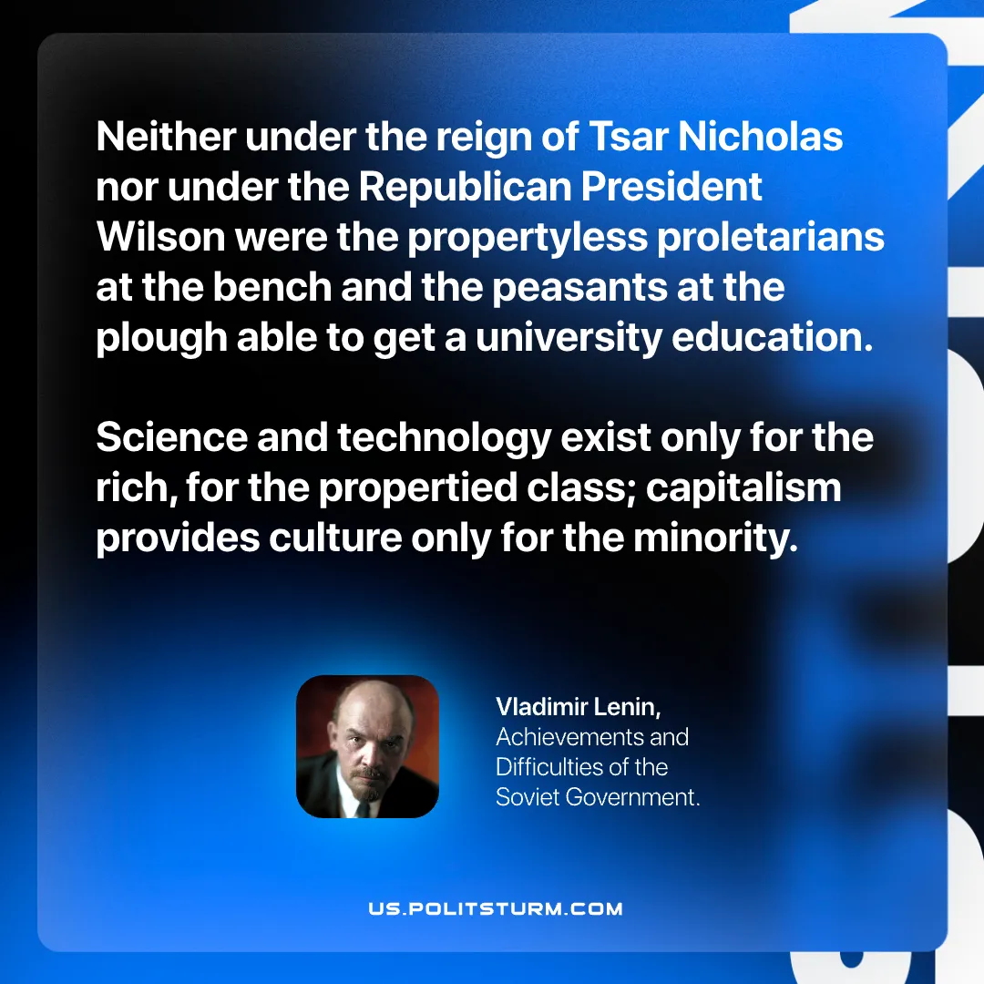

Original article
2026-06-06

Neither under the reign of Tsar Nicholas nor under the Republican President Wilson were the propertyless proletarians at the bench and the peasants at the plough able to get a university education.
Science and technology exist only for the rich, for the propertied class; capitalism provides culture only for the minority.
Vladimir Lenin, Achievements and Difficulties of the Soviet Government.

Original article

