Lenin on the Exclusion of the Poor from Politics
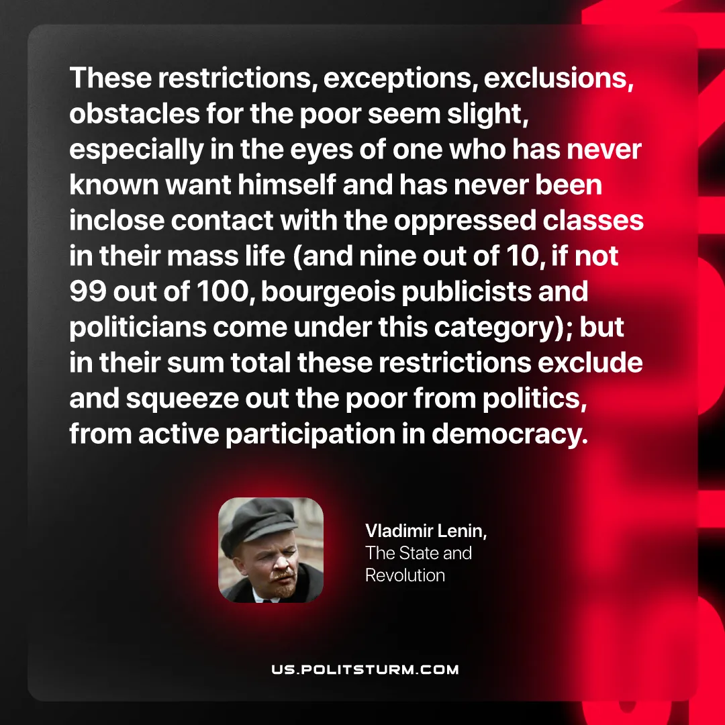

Original article
2026-08-25

These restrictions, exceptions, exclusions, obstacles for the poor seem slight, especially in the eyes of one who has never known want himself and has never been in close contact with the oppressed classes in their mass life (and nine out of 10, if not 99 out of 100, bourgeois publicists and politicians come under this category); but in their sum total these restrictions exclude and squeeze out the poor from politics, from active participation in democracy.
Vladimir Lenin, The State and Revolution

Original article

