Lenin on the Essence of Communist Activity
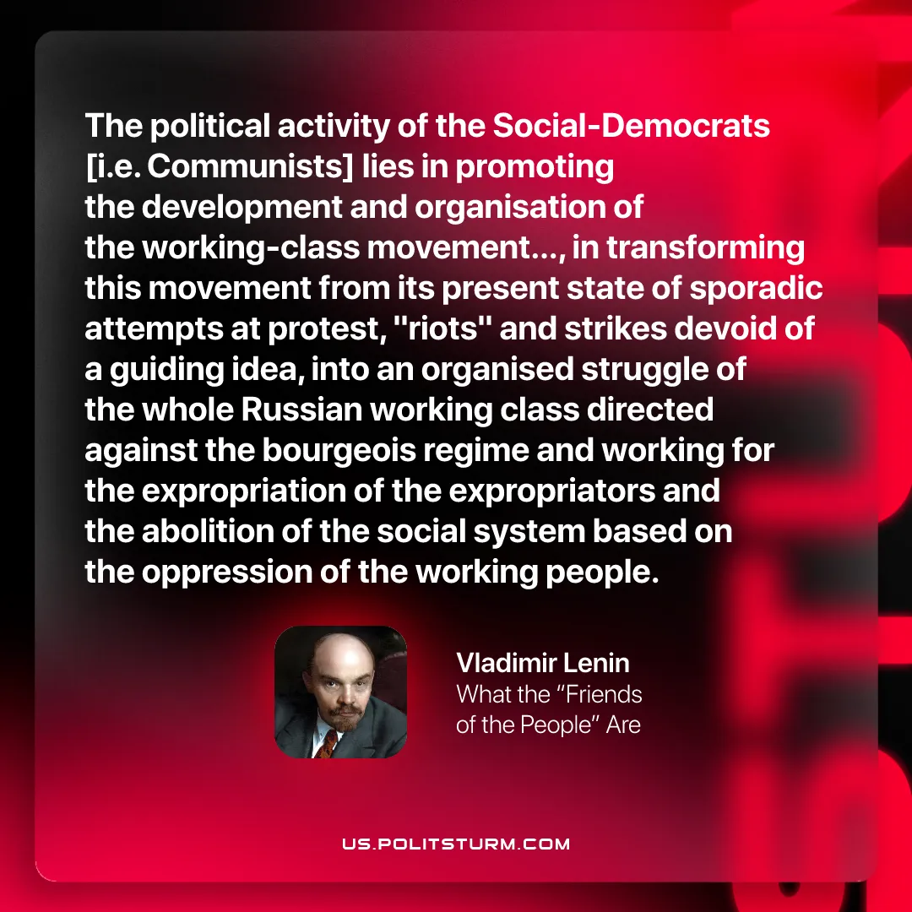

Original article
2026-01-15
1 min read

"The Political activity of the Social-Democrats [i.e. Communists] lies in promoting the development and organisation of the working-class movement..., in transforming this movement from its present state of sporadic attempts at protests, "riots" and strike devoid of a guiding idea, into an organised struggle of the whole Russian working class directed against the bourgeois regime and working for the expropriation of the expropriators and the abolition of the social system based on the oppression of the working people."
Vladimir Lenin, What the "Friends of the People" Are

Original article

