Lenin on the Enlightenment of Workers and Criticism of Trade-Unionism
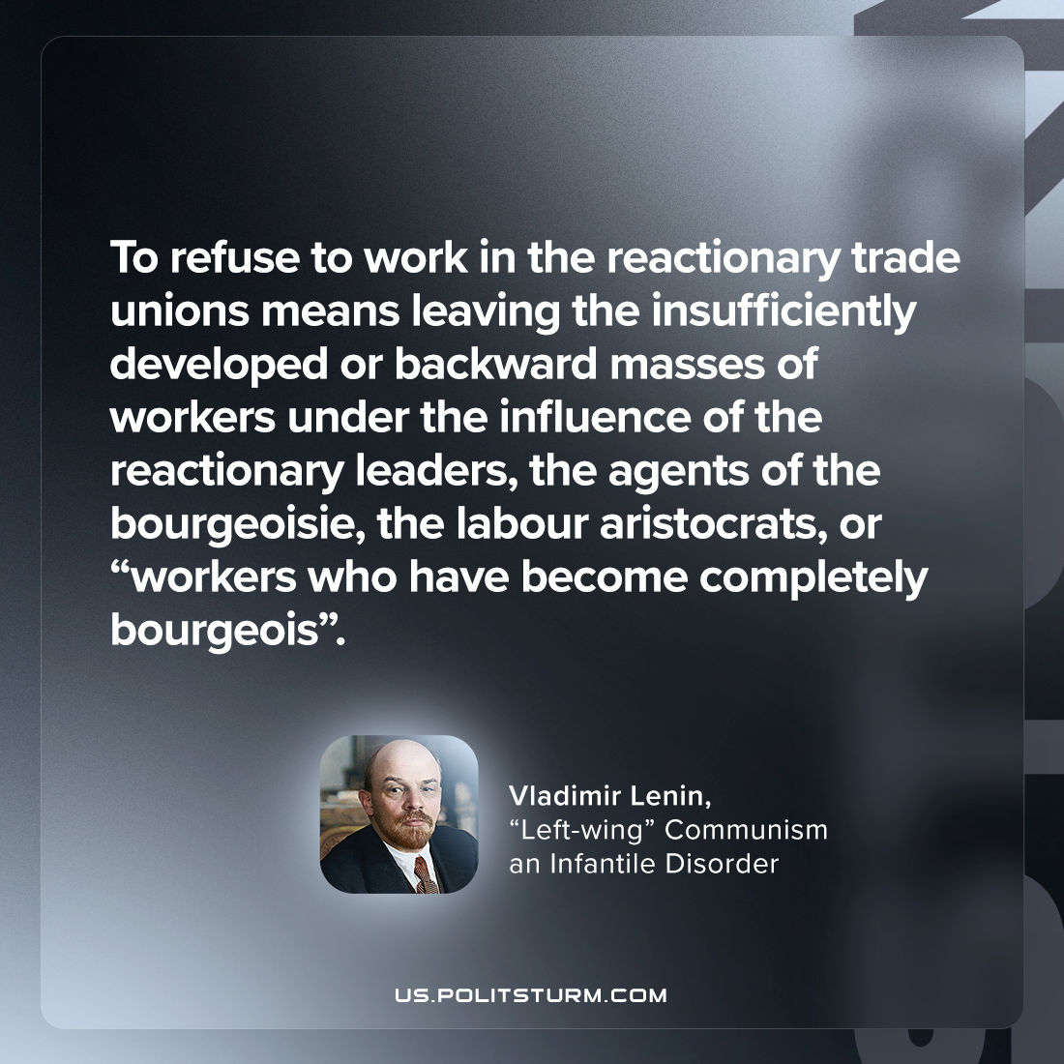

Original article
2023-09-23

"To refuse to work in the reactionary trade unions means leaving the insufficiently developed or backward masses of workers under the influence of the reactionary leaders, the agents of the bourgeoisie, the labour aristocrats, or “workers who have become completely bourgeois”."
Vladimir Lenin, “Left-wing” Communism an Infantile Disorder

Original article

